Part 1 Directions
Choose two of the following resources to review. As you review, track what each says about
confirmation bias and fake news. Capture your thoughts in the notes section. Review additional resources as time allows.

Resource 1
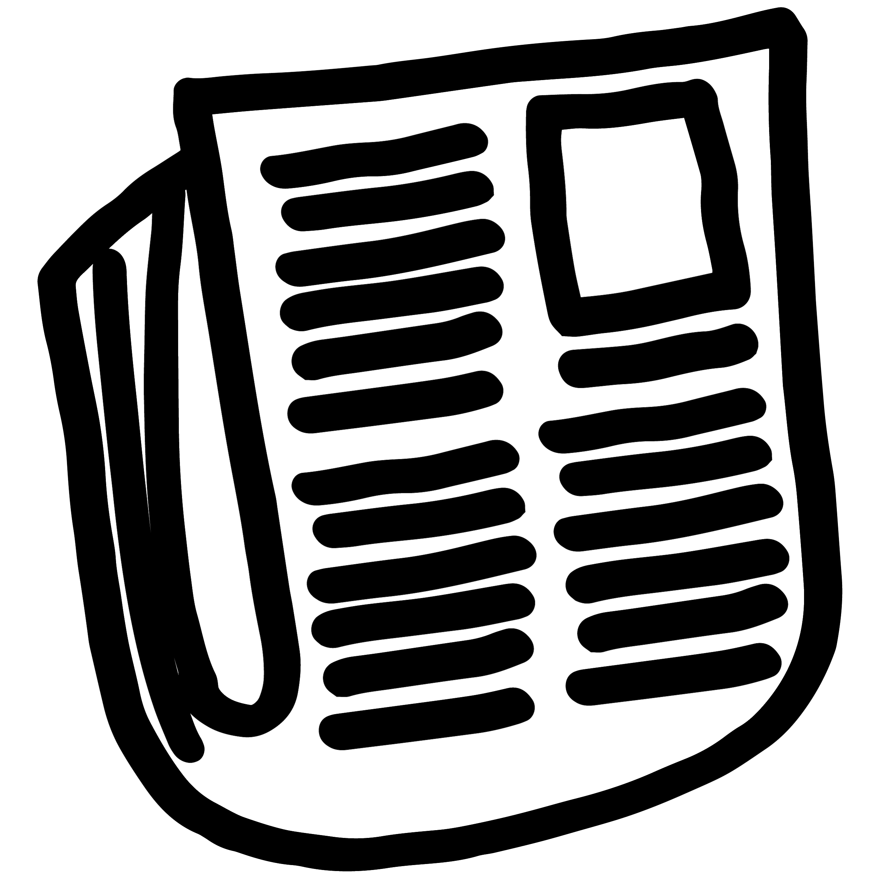 | Read: Cover Up, Your Confirmation Bias Is Showing  JESSIE SMITH, MEDIUM.COM, 11/6/2018 (10 MINS.)  Link: https://medium.com/swlh/cover-up-your-confirmation-bias-is-showing-9ff380d21925

Resource 2
Watch: Defining Confirmation Bias
FACING HISTORY AND OURSELVES, 2019 (2 MINS.)
Link: https://www.facinghistory.org/resource-library/video/defining-confirmation-bias

Resource 3
Read: Scientists Discover Simple Psychological Tools to Battle Fake News
PETER HESS, INVERSE.COM, 8/13/2018 (10 MINS.)
Link https://www.inverse.com/article/48022-how-can-we-overcome-confirmation-bias

Notes Tracker:
Resource # | What does this resource show about confirmation bias and fake news? | How can we challenge  confirmation bias, especially  with information we see online?

