Current Issues Daily Log – August 15-19, 2016
Part One: Choose 2 topics covered in today’s newscast and provide basic information (W,W,W,W,W,H).
Part Two: Choose 1 of the following topics to discuss in 4-5 sentences.
- U.S. Olympic Athletes have to pay taxes on medals and any prizes won at the Olympic Games. Do you agree or disagree with this? Why?
- What do you think we can do in our community to help the homeless population? What challenges would be faced in trying to set up some of the assistance programs?

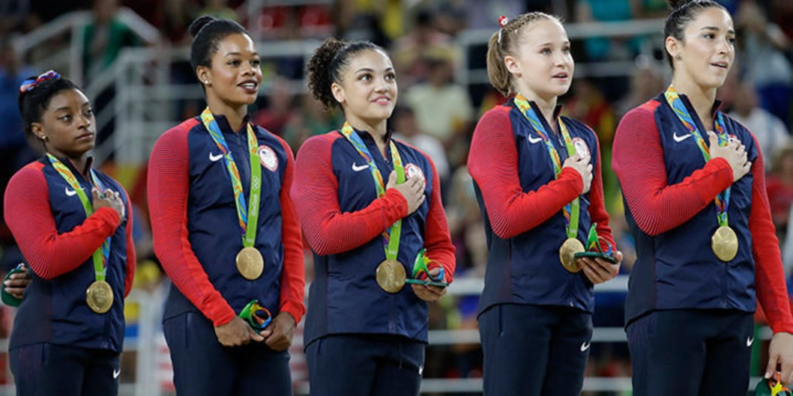
August 16, 2016
Olympic Gymnast Gabby Douglas
has received a lot of criticism for
not having her hand over her heart
during the U.S. National Anthem.
One response to this criticism
states: “Being American means the
right to not put your hand over your
heart during the National Anthem.” Do you agree or disagree with this statement? Why?

August 17, 2016
Part One: Choose 2 topics covered in today’s newscast and provide basic information (W,W,W,W,W,H).
Part Two: Choose 1 of the following topics to discuss in 4-5 sentences.
- Do you think the Guantanamo Bay prison should be closed? Why/Why not?
- What do you think about traditional cable versus internet cable? Name an advantage and disadvantage of both.
August 18, 2016
Part One: Choose 2 topics covered in today’s newscast and provide basic information (W,W,W,W,W,H).
Part Two: Choose 1 of the following topics to discuss in 4-5 sentences.
- What do you think about the Prism technology that allows retailers to track people in the store? Is this similar or different than how you view online retailers tracking your shopping/search habits?

August 19, 2016
Select one of the images to the left.
Describe what you see in the image.
Explain why this might be different than what
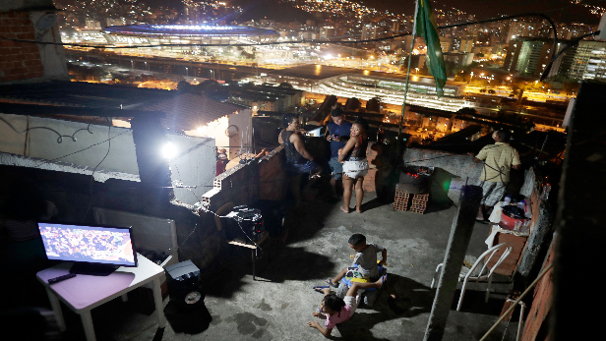
has been shown during the Olympics news coverage.

