Daily Log – Week One
August 8, 2016
Answer the following question in 4-5 sentences.
Michael Phelps has won a total of 23 Olympic medals. He is the most decorated athlete in Olympic history. Do you think that there should be a maximum number of medals an athlete can win? Why or why not?

August 9, 2016
Below is a list of all of the sports that will be played in the 2016 Summer Olympics. Complete both of the following. (4-5 sentences)
- Choose ONE sport to eliminate and explain WHY.
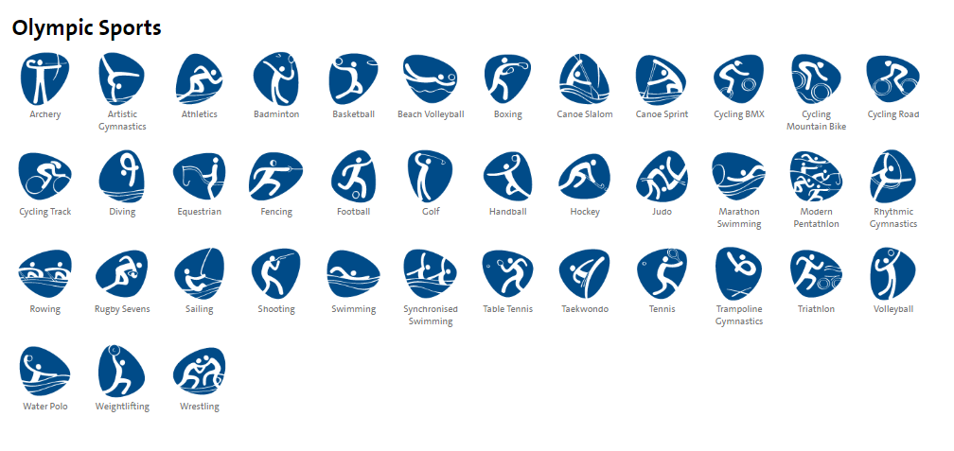
- Choose ONE sport to add and explain WHY

August 10, 2016
Should the federal government be responsible for oversight of amusement parks? How should injuries, fatalities, or other emergencies be handled? Who is responsible?
August 11, 2016 --- Choose ONE
Each member of the "Final Five" has eight custom-fitted competition leotards decorated with 3,500 to 5,000 swarovski crystals -- and the uniforms cost between $700 and $1,200 each. What do you think about spending so much money for something like this? Would you be concerned that you would only wear it a few times or no?
Xavier University in Ohio has installed the nation’s first official Pizza ATM. What do you think about this Pizza ATM? Would you buy it or not? Why?

August 12, 2016
The financial cost of the 2016 Olympic Games in Rio is approximately $4.6 billion. What are some advantages and disadvantages of hosting the Olympics?

