Name: ______________________________
Exploring Document Based Questions: Context
Objective: SWBAT practice the point-scoring DBQ skill of contextualization by writing essay-beginning contextualization statements to multiple DBQ essay prompts.
Directions: As many of you have seen in my class text messages, or by continuing to track this important information on your own, the Collegeboard has decided that for the modified AP exam this year the format will be a DBQ. In order to make it more doable in 45 minutes, they have reduced the number of documents to five, and simplified the rubric to what you see here.
This week, we will spend each day isolating individual scorable skills and practicing them. Today, we will be targeting what is likely to be the first point you may score in your response: contextualization.
For each of the DBQ questions shown below please write your contextualization statement that you would use to begin this essay. If you remember, these statements are generally how you start your essay, and act as a way to frame your argument within relevant historical context. If you need help remembering how they should look/sound, see my example below, or watch the scrolling intro to any Star Wars movie on youtube (talk about contextualization!).
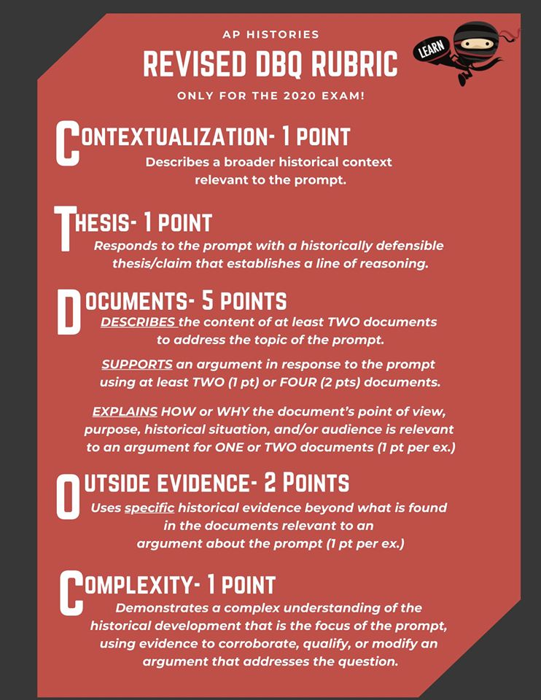
Example of Scoring Contextualization for a DBQ Question:
Using the documents provided, evaluate the effects of various strategies implemented by governments that promoted their own state-sponsored visions of industrialization during the period 1750-1900 CE.

From the late-18th century to the late-19th century, the world underwent dramatic political change as traditional powers in the world fell and new powers rose to dominance. For most of the last 500 years, empires like China and the Ottomans gathered enormous power throughout their regions from their economic dominance of long-distance trade routes and areas like Western Europe and Russia were by comparison much weaker. This all changed, however, when the industrial revolution began in England and was soon adopted by many countries who used it in place of historical trade routes to become new global powers.

- Using the documents provided, evaluate the extent to which the Industrial Revolution negatively impacted the lives of women and children in industrial societies during the nineteenth century.

- Using the documents provided, evaluate the causes of the rise of nationalism throughout the world during the period 1750-1900 CE.

- Using the documents provided, evaluate the extent to which Christianity changed societies in Latin America in the period 1500–1800.

- Using the documents provided, evaluate the extent to which the Chinese embraced Westernization in the period 1850 to 1920 CE.

- Using the documents provided, evaluate the range in African responses to European imperialist actions.

