Name: ______________________________
Exploring Document Based Questions: Thesis Creation
Objective: SWBAT practice the point-scoring DBQ skill of writing a thesis statement that directly responds to the question being asked in three 5-document mini-DBQ’s
Directions: In keeping with this week’s theme of isolating individual scorable DBQ skills and practicing them, today we will be targeting arguably THE MOST critical skill piece in your writing, the Thesis. As I’ve mentioned to you multiple times this year, on this point most of the others rest, and data shows clearly that students who earn the thesis point on average pass, and students that don’t, fail.
I will provide you the full 5-documents for three of the DBQ questions you have seen throughout the week, and you will be asked to breakdown the question and apply it to each of the documents in a way that reveals their answers and allows you to then make your argument- the thesis.
Remember, if you want to self-check your thesises (thesi?) for whether they are likely to score, read the question, then immediately read your thesis right after. Then, do that process over again. If your thesis does not directly reply to the question, it’s not going to work and you should try again.
Please see the example I provide for a reminder of how a scoreable thesis should look/sound.

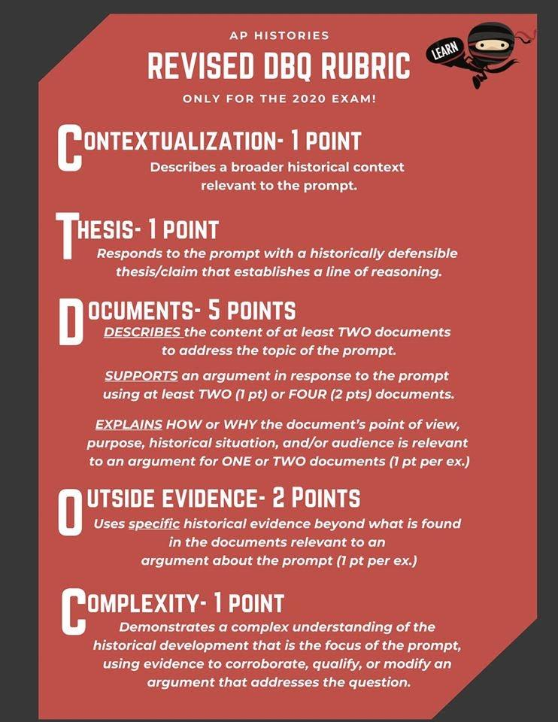
Using the documents provided, evaluate the effects of various strategies implemented by governments that promoted their own state-sponsored visions of industrialization during the period 1750-1900 CE.
State-sponsored industrialization during the period 1750-1900ce often led to rapidly growing national economies, the construction of large-scale infrastructure projects to unify a nation, and the generation of thousands of new jobs for workers of that country.

PRACTICE
- Using the documents provided, evaluate the extent to which the Industrial Revolution negatively impacted the lives of women and children in industrial societies during the nineteenth century.

Document 1

Buddhist Priest from a rural area of Japan from which many farm girls were sent to work in the mills, circa 1900.

“The money that a factory girl earned was often more than a farmer’s income for the entire year. For these rural families, the girls were an invaluable source of income. The poor peasants during this period had to turn over 60% of their crops to the landlord. The peasants’ only salvation was the girls who went to work in the factories.”

Document 2

Testimonies from miners in southern Wales to British Parliament members interested in gathering information to improve the protection of children in mines and factories about 1842.

Six year old girl:
"I have been down six weeks and make 10 to 14 rakes a day; I carry a full 56 lbs. of coal in a wooden bucket. I work with sister Jesse and mother. It is dark the time we go."

Maria Gooder:
"I hurry [carry goods] for a man with my sister Anne who is going 18. He is good to us. I don't like being in the pit. I am tired and afraid. I go at 4:30 after having porridge for breakfast. I start hurrying at 5. We have dinner at noon. We have dry bread and nothing else. There is water in the pit but we don't sup it. "

Mary and Rachell Enock (ages 11 and 12 years):
"We are door-keepers in the four foot level. We leave the house before six each morning and are in the level until seven o'clock and sometimes later. We get 2 pence a day and our light costs us 2 1/2 pence a week. Rachel was in a day school and she can read a little. She was run over by a tram a while ago and was home ill a long time, but she has got over it."

Document 3

A female Chinese worker tells her life story to an American suffragette about 1900.

“Between what my mother could earn and what we could grow these were the best times for my family. My two older sisters were married during these good times to farmers who owned more land than we did. Unhappily, everything turned to dust for us.
Soon my mother lost her job as a spinner. They say it was cheaper for the weavers to import the cotton spools of foreigners than have us spin it.
I was fortunate to be living in Kiangsi province because of the cotton grown there: Chang Chien built the first privately owned textile mill at Nan-t’ung, my home town, and my mother and I were able to get jobs because of our experience as spinners. When we came to work we were forced to sign this Factory Agreement which told us what we would be paid, how long we had to work, and what would happen if we got sick.
Combined with the wages of my mother and father we can survive and I can even hope to marry one of the other factory workers. We like the factory worker's life much better than the life of a woman on a farm. We are much freer working in the factory and less under the domination of the men of the family than we would ever have been on the farm. Our only fear is if our factory can't sell its goods, we may lose our jobs. We do not have the slightly greater security of farm life.”

Document 4

Breaker boys (a worker whose job was to separate impurities from coal by hand. Although breaker boys were primarily children, elderly coal miners who could no longer work in the mines because of age, disease, or accident were also sometimes employed. The use of breaker boys began in the mid-1860s), the smallest boy is Angelo Ross. Pittston, Penn.

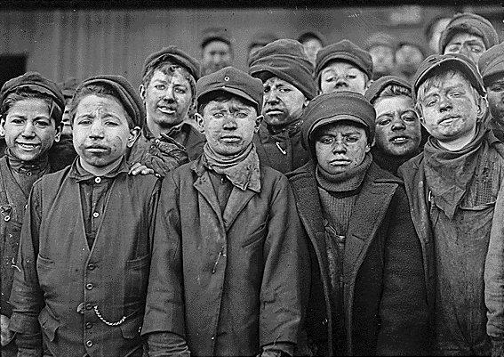

Document 5

Hannah Richardson, a British worker, from her testimony before the Ashley Committee on the Conditions in Mines, 1842. The Ashley committee was a Parliamentary committee investigating abuses in the coal industry.

“I’ve one child that works in the pit; he’s going on ten. He is down from 6 to 8…He’s not much tired with the work; it’s only the confinement that tires him. He likes it pretty well, for he’d rather be in the pit than go to school. There is not much difference in his health since he went into the pit. He was at school before, and can read pretty well, but can’t write. He is used pretty well; I never hear him complain. I’ve another son in the pit, 17 years old… He went into the pit at eight years old. It’s not hurt his health nor his appetite, for he’s a good size. It would hurt us if children were prevented from working till 11 or 12 years old, because we’ve not jobs enough to live now as it is…”

Your Thesis:

- Using the documents provided, evaluate the causes of the rise of nationalism throughout the world during the period 1750-1900 CE.
Document 1

Source: Claude Joseph Rouget de Lisle, French army office of the French Revolutionary War, song originally titled “Chant de guerre pour I’Armee du Rhin” (“War Song for the Rhine Army”) written after the declaration of war by France against Austria, later renamed La Marseillaise, the national anthem of France, 1792.

Arise, children of the fatherland,
Our day of glory has arrived.
Against us cruel tyrants.
Have raised their bloody flag.
Do you hear in the countryside
Their fierce hired soldiers?
They come almost into your arms
To attack your children and your fields.
Chorus To arms, citizens!
Form your battalions!
March on, march on,
To liberty or death!

Document 2

Source: Otto von Bismark, prime minister of Prussia from 1862-1872 and then of the united Germany until 1890, Blood and Iron, 1866

Prussia ... could no longer carry alone the power that Germany required for its security. That must be equally distributed over all German peoples. We would get not nearer our goal by speeches, associations, or decisions by the majority... This contest could only be settled by blood and iron. There is one way to guarantee our success. The deputies must place the greatest possible weight of blood and iron in the hands of the King of Prussia.

Document 3

Source: Giuseppe Girabaldi to his soldiers during Italian Unification, 1860

O noble Thousand! ... I love to remember you! ... Where any of our brothers are fighting for liberty, there all Italians must hasten! -such was your motto. Let him who loves his country in his heart, and not with his lips only, follow me.

Document 4

Source: Tokugawa Nariaki, a member of the Tokugawa family and Japanese advocate of reform, Memorandum to the Bakufu, 1853

Though the Rangakusha* group may argue secretly that world conditions are much changed from what they were,…seclusion in isolation admist the seas…is a constant source of danger to us and that out best course would therefore be to communicate with foreign countries and open an extensive trade; yet, to my mind, if the people of Japan stand firmly united, if we complete our military preparations and return to the state of society that existed before the middle ages, then we will even be able to go out against foreign countries and spread abroad our fame and prestige. But if we open trade at the demand of the foreigners, for no better reason than that…men have shown fear merely at the coming of a handful of foreign warships, then it would truly be a vain illusion to think of evolving any long-range plan for going out against foreign countries.

*Rangaku or “Dutch knowledge”; Rangakusha are the scholars of western knowledge

Document 5

Source: Simón Bolívar, Venezuelan soldier and statesman who led the revolutions against Spanish rule in the Viceroyalty of New Granada (Latin America), Letter from Jamaica, 1819

Success will crown our efforts because the destiny of Latin America is irrevocably fixed; the tie that bound her to Spain is severed…. The hatred we feel for the Peninsula [the Iberian Peninsula] is greater than the sea separating us from it; it would be easier to bring the two continents together than to reconcile the spirits and the minds of the two countries. The habit of obedience, a commerce of shared interests, knowledge, and religion; mutual goodwill; a tender concern for the birthland and glory of our ancestors; in brief everything that constituted our hopes came to us from Spain….Today the opposite is true: death, dishonor, everything harmful threatens us a makes us fearful. That wicked stepmother is the source of all our sufferings….. The chains have been broken, we’ve been liberated, and now our enemies want to make us slaves. That is why America fights with such defiance, and it would be rare should such desperate intensity not bring victory in its wake…. We are moreover neither Indians nor Europeans, but a race halfway between the legitimate owners of the land and Spanish usurpers – in short, being Americans by birth and endowed with rights from Europe – find ourselves forced to defend these rights against the natives while maintaining our position in the land against the intrusion of the invaders. Thus we find ourselves in the most extraordinary an

Your Thesis:

- Using the documents, evaluate the extent to which Spanish colonial rule affected indigenous populations in South America
Document 1

Source: Bartholomew de las Casas, Dominican priest, Short Report of the Description of the Indies, 1552 CE

In the year 1526, by lying and deceiving and by making offers to the King, another unhappy man was elected governor of the kingdom of Yucatan. … This tyrant, with three hundred men began by making cruel war on those good and innocent people, who kept within their houses without offending any one. The country produces no gold, and if it had he would have used up the people by working them in the mines; to coin gold therefore out of the bodies and souls of those for whom Jesus Christ died, he made slaves indifferently of all whom he did not kill; many ships were attracted thither by the news that slaves were to be had, all of which he sent back loaded with human beings whom he sold for wine, oil, vinegar, pork, clothing, horses and whatever else he and his men thought they needed. … He continued with these operations ruining and depopulating those countries, and killing those people without pity, till news of the riches of Peru reached the place and the Spaniards left him, and that hell ceased for some days. Afterwards, however, his ministers returned to commit more great evils, robbery, wickedness, and great offence against …These then are the deeds of the Spaniards who go to the Indies; in their desire for gold they have numberless times sold, and do sell, and have forsworn Jesus Christ.

Document 2
Source: Jose de Acosta, Jesuit Priest in Peru, a letter to the Spanish King, 1585

Throughout this realm there are many Blacks, mulattoes, mestizos and many other mixtures of people, and every day their number increases ... These people grow up with great vices and [excessive] liberty, without working nor having any trade, and they are often to be found drinking or engaging in witchcraft. Those [Spaniards] who reflect on this matter with care, fear that in time the number of these [castas] will become much larger than that of the children of Spaniards born here (who are called criollos)... and that therefore they will be able to raise a city in revolt; and if they so raise one city, an infinite number of Indians would join them, since they are all of one casta, and understand each others' thoughts because they have been raised together ... and if so many joined together, it would be easy for them to take all the cities in this realm [Peru] one by one ...

Document 3
Source: Guaman Poma, Christian Peruvian nobleman, New Chronicle and Good Government, 1615

The Ministry should also foment and expand the introduction of Negros because they, and their descendants, as people of mixed blood (Castas) opposed to the Indians, will serve to counteract [Indians’] forces and they will be beneficial to the support of agriculture and the other professions (Artes). No measure has been more effective in the present revolutions than that of opposing some provinces against others, and being natural the antipathy of the Negro and his predominance over the Indio, we will succeed by this method to present to them [the Indians], in times of necessity, an irreconcilable and powerful enemy.

Document 4
Source: Jose Antonio de Areche, Spanish Vistador (representative of the King), Execution Order against Tupac Amaru II, 1781

To this same end, you should prohibit that the Indians wear pagan clothes, especially those who belong to the nobility, since it only serves to represent those worn by their Inca ancestors, reminding them of memories which serve no other end than to reconcile them more and more in their hatred toward the dominant nation…

Document 5
Source: Mercurio Peruano, newspaper account of peoples departing for mit’a labor, 1792

The Indians that go to Potosi and its refining mills leave their homeland with great mournfulness… The day of their departure is very sad … [After mass] they pay [the priest] in order to entreat from them all-powerful success in their journey. Then they leave for the plaza accompanied by their parents, relatives and friends; and hugging each other with many tears and sobs, they say goodbye. Followed by their wives and children, they take to the road preoccupied with their suffering and depression. The doleful and melancholy nature of this scene is augmented by the drums and the bells that begin to signal supplications.
Your Thesis:

