Digital Literacy PSA Assignment

Public Service Announcement

For this assignment, you will brainstorm ideas, come up with a concept, write, plan, and record a Public Service Announcement (PSA) that focuses on a topic related to Digital Literacy based on the suggested topics below. Use the guidelines below to begin to conceptualize a 60-second PSA.

Suggested topics:

- Impact of Fake News
- Confirmation Bias
- Recognizing Credible Sources
- Recognizing Fake News/Images
- Organizations Attempting to Stop Fake News
- Being a good digital citizen

Media messages are fleeting. One compelling central message, clearly presented with a simple call to action, is the most effective way to get your point across.

Answer the following questions to begin:

1. Target Audience: Who do I want to reach with my message?

2. Message: What is my message? What do I want the viewer to understand?

3. Action Step: What is the call to action? What do I want the viewer to do? How can the viewer help solve the problem?

4. Significance of Issue to the Public: Why is this issue important to the public?

Required components of the project:

1.Turn in a written description of the PSA, answering questions 1-4, plus any other information and research about the issue, or the population the PSA addresses or serves.

2. Complete the attached storyboard & write a script BEFORE you begin shooting. A storyboard is a visual representation of the different shots (shot sketches) in the order they will appear in the finished work, and includes compositional information (close up, pan, wide shot, etc.), as well as audio (where the narration comes in, or if there is music over the shot). Your drawings can be simple stick figures. The script will help you focus on what you want to say/how to say it. (It also will make recording your PSA easier!

3. Record your 60 second PSA using Flipgrid or similar platform.

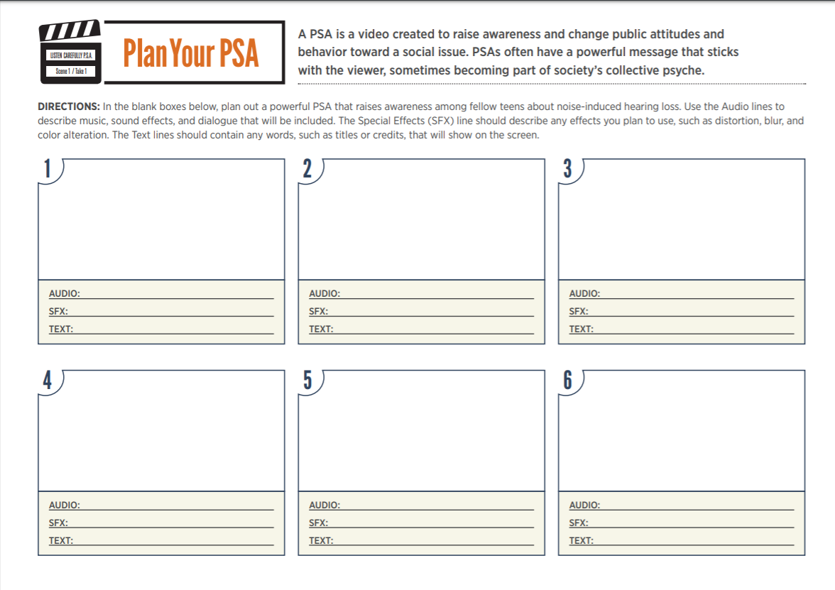
topics related to digital literacy

