World History Syllabus
Instructor: Mrs. Matello
E-mail: Mary.Sanderson@cobbk12.org
Blog: http://mrsmatellosclassroom.weebly.com/

Classroom Number: 118F

Instructor: Mr. Campbell
E-Mail: Kenneth.Campbell@cobbk12.org

Course Description: World History is course is a study of people and nations of both Western and non-Western societies. Problem solving and critical thinking skills will be developed. In the course of this semester, we will cover ancient history through the modern period, and by understanding the history of your world, you will understand how we came to be where we are today. It is my hope that this understanding will make you concerned and productive citizens who understand and appreciate cultures other than your own.

Classroom Policy: Students should come to class with all of the necessary materials for the day; this will always include the list of materials below. Additionally, in order for us to successfully learn about the diversity of the world, we must all be open minded and treat each other with the utmost respect.

Materials: The following are materials that you must have in class every day

1. Pens/Pencils
Additional supplies NEEDED for classroom
- Markers - Highlighters
- Scissors - Copy Paper
- Colored Paper - Tissue
- Colored Pencils - Tape
Donations would be GREATLY appreciated!!!

2. Paper

3. Notebook

Required Text: McDougall Littell : World History: Patterns of Interactions. I will provide a classroom set of textbooks. These books MUST remain in the classroom. Students may check out a textbook
from the Media Center at their own discretion.
Online Textbook http://www.nasoa.com/School%20Folder/World%20History/Textbook%20page.htm
Online Textbook Glossary http://www.scribd.com/doc/28003615/world-history-Patterns-of-Interaction-Glossary#scribd

Attendance: Students should be in class on a daily basis. We have 18 weeks to cover thousands of years’ worth of human history. Your success in this course depends on your attendance. In the event of an absence, it is YOUR responsibility to get the work, copy any notes from a fellow student, and make arrangements to make up any missed tests or quizzes during Study Hall from 7:30-8:15 each morning or by appointment
after school. Make up work should be turned in within 3 school days of the excused absence. MAKE UP WORK WILL NOT BE ACCEPTED AFTER THE 6 WEEK GRADING PERIOD IN WHICH IT WAS ORIGINALLY ASSIGNED!

Tardiness: Students are expected to arrive and be in the classroom on-time when the final bell rings. If you are tardy, you need to either bring a signed pass from another teacher or the administrative policy will be followed.

Behavior Expectations:
- Above all, I ask three things of you: respect me, respect others, and respect yourself.
- Students need to take care of personal business before entering the classroom. If you need to leave the classroom for any purpose, written permission from the teacher must be obtained. Passes will be issued at the discretion of the teacher.
- Students must put their first and last name on the top of all assignments to receive credit. No-name work will not be graded, until identified with a writing sample from the student.
- Cheating in ANY FORM will not be tolerated. It will result in an automatic zero for the assignment and further disciplinary options.
- Per the school policy, students should not use cell phones during class time except for instructional purposes determined by the teacher. If a student’s cell phone becomes a distraction or is used inappropriately, it will be collected.

Course Framework: As a World History course, our content is limitless. It can be highly interactive and collaborative, so long as students actively participate in and outside of class. Below is a general framework of the course:
- Notes: Notes are the backbone of this class, so you will likely take notes every day in a variety of forms (i.e. lecture, video, activities, and projects.) The majority of quiz/test content will come from the notes taken in class. As such, it is crucial for students to keep up with ALL notes from class. Additionally, if you miss class, you NEED to be sure to get notes from a classmate.
- Notebook: Students will be required to maintain a notebook for World History, separate from other courses. This notebook will contain warm-ups, notes, classwork, and other miscellaneous assignments. Notebooks will be turned in and graded and the end of each unit and will be part of the classwork/project category. At the end of the course, you will have a perfect study tool for the final exam. The notebooks will be kept in the classroom, unless given specific permission from the teacher.
- Homework: All homework is due at the beginning of class on the assigned due date, unless otherwise specified. Additionally, students should spend 10-15 each night reviewing notes and other course content (maps, handouts, videos, etc.) A little studying early on will help you much more than one night of cramming.
- Projects: Projects will involve a variety of formats and mediums.
- Benchmarks: We will measure our progress through the course using benchmark tests. These will cover larger chunks of content than a typical unit test. Benchmarks will be announced at least one week in advance. Tests may consist of both multiple choice/matching and written sections.
* If a student is absent the day before a test (review day), that does not excuse them from taking the test.
- Assessments: In addition to the benchmark tests, we will use a wide variety of assessments to measure a student’s content and skill mastery throughout the semester. These assessments may include written prompts, quizzes, and other types.

Grades Determination:

Benchmarks 30%
Projects 15%
Assessments/Quizzes 15%
Daily Work (Classwork/Homework 20%
Final 20%

Tutoring: Tutoring/Study Hall is available daily from 7:30-8:15AM and in the afternoons by appointment. Please make arrangements with me to come in/stay after for a make-up or help. NOTE: It is the responsibility of the student to inform parents/guardians and arrange transportation when attending study hall.

Disclaimer: I reserve the right to alter this syllabus when it is deemed to be in the best interest of the students.

Online Textbook Online Textbook Glossary
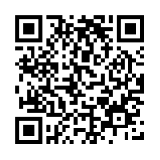
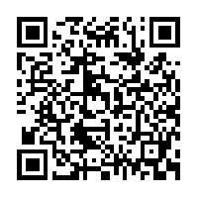

Classroom Blog Join World History Remind
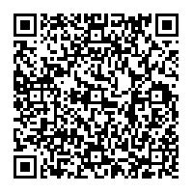
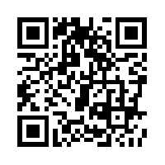

Syllabus Receipt

We have read Mrs. Matello’s class syllabus and we understand the requirements, rules, expectations and procedures of her class. Please be sure to fill out and sign below and return it to Mrs. Matello by Wednesday August 10, 2016.

Print Student Name _______________________________________________________

Student Signature _________________________________________________________

Print Parent/Guardian Name ______________________________________________

Parent/Guardian Signature ________________________________________________

Parent/Guardian Preferred Form of Communication: Email Phone

Parent/Guardian Email ___________________________________________________

Parent/Guardian Phone Number____________________________________________

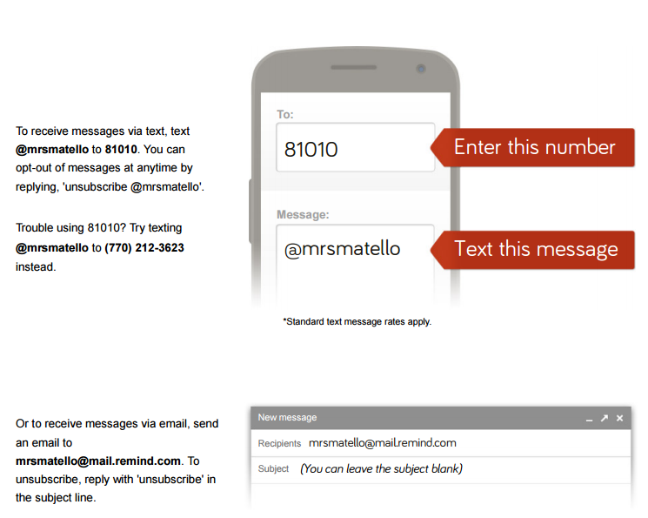
Mrs. Matello’s
World History
Remind Sign Up
Info

Video Permission Slip

A variety of films and video clips will be used throughout this course in order to help provide students with a well-rounded understanding of the different topics related to this course. While all of the videos used will be relevant to the course curriculum and content, some of the videos may be rated PG-13 or R. The teacher will use appropriate discretion when showing full length films.

______ Yes, I give my son/daughter permission to view curriculum and school appropriate full-length movies rated PG-13 or R.

______ No, I do not give my son/daughter permission to view curriculum and school appropriate full-length movies of the types mentioned in this letter. I understand alternate learning experiences will be provided for my child while the movie is being watched.

Parent/Guardian signature ____________________________________________________

