The Bantu Migration
A migration is a movement of peoples across the landscape. Migrations often spread the cultural practices and languages of those spreading into new areas. Sometimes those new cultures and language are assimilated into the cultures and languages which already exist within the new areas, sometimes creating a whole new culture or language. The Bantu Migration in Africa is an example of just such a migration.

People on the Move
Armed with iron smelting technology the Bantu of west and central Africa dispersed across the continent, changing its linguistic and cultural landscape. A number of theories have been put forward to explain this migration.
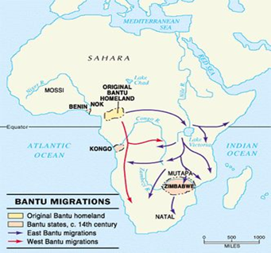
SLOW BUT STEADY
One theory is that there were waves of migration, one moving through the east of Africa and another making its way through the center of the continent. In Zambia, there is evidence of at least three routes of migration - from the great lakes, from the Congo forest and from Angola.
There is evidence that the Bantu ancestors of the modern Swahili peoples mastered sailing technology and possessed canoes and boats so they could make their way along the Zambezi river.
CONQUERORS, COLONIZERS OR ADVENTURERS?
Most historians appear to believe that rather than arriving en masse like a conquering horde, the migrations were more sporadic with small pockets of people moving from one point to another.
It is not entirely clear how the Bantu reacted when they came upon existing communities but it is likely that there was considerable absorption, assimilation and displacement of other peoples during the migration period. The Bantu were armed with superior weapons and their iron implements allowed them to cultivate land and clear forests efficiently.
If they came as colonizers, then it is unlikely to be in the sense we understand the term today.
Historians believe there was social interaction and intermarrying and trade.
EVIDENCE
The evidence for migration is based on three main areas of research. They are:
- Linguistic
A comparative study of languages spoken in some parts of eastern, central and southern Africa show similarities with the mother tongues originally spoken in West Africa. There are some 450 known languages in the Bantu family from Gikuyu in the north to Setswana in the south.
- Pottery
There is evidence of similar pottery technology in eastern, southern, and western Africa. Iron Age farmers were skilled pot makers and decorated their pots with grooves and patterns. Related groups of peoples used similar styles of decoration.
- Iron
There is little or no evidence of iron working in east and southern Africa before the arrival of the Bantu suggesting that new technology was spread by the migrants.
The Bantu proved enormously successful at adapting to their new environments and it has been argued by some historians that they brought not only new methods of survival but the development of the system of statehood that we still find today.

In your own words, define assimilated. ________________________________________________________
_________________________________________________________________________________________

What evidence makes historians think that the Bantu Migration was “slow and steady”? ______________ __________________________________________________________________________________________
__________________________________________________________________________________________
Do you think the Bantu were conquerors, colonizers, or adventurers? Why? ________________________
__________________________________________________________________________________________
__________________________________________________________________________________________
What are the three major types of evidence of the migration?
- 2. 3.
Discuss each type of evidence. (How does it support the migration theory?) ________________________
__________________________________________________________________________________________
__________________________________________________________________________________________
__________________________________________________________________________________________
__________________________________________________________________________________________

