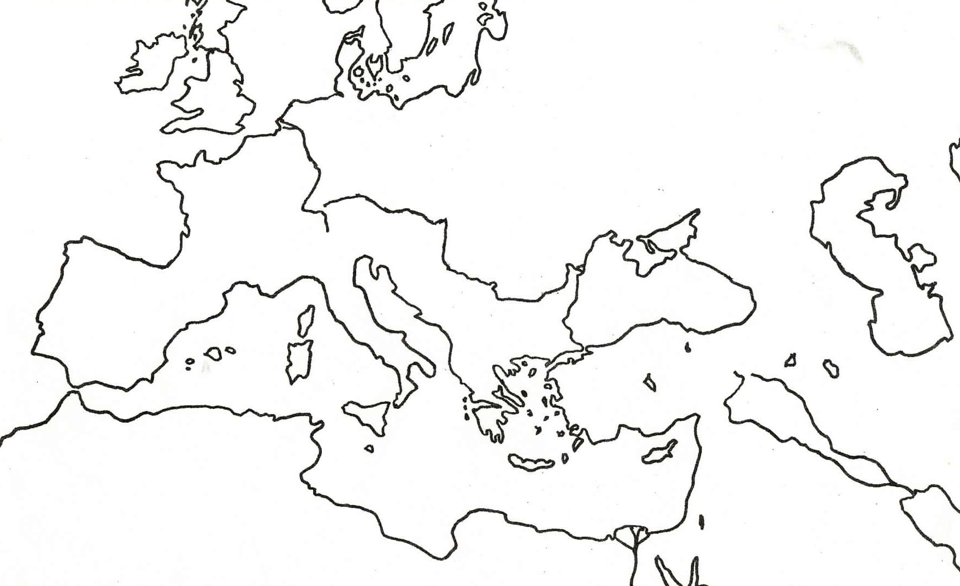

On the map above, label the following items:
- Italy - Mediterranean - Byzantine Empire
- Greece - Rome
- Atlantic Ocean

Define the following:
- Polis

- Direct Democracy

- Republic

- Alexander the Great

- Plebian

- Patrician

- Caesar Augustus

- Constantinople

- Justinian’s Code

What did you have to own to be a citizen in Athens?

Why couldn’t the Greeks be wholly united?

What was the Greek’s main means of trade?

Discuss the similarities and differences between Sparta and Athens.

What cultures were combined to create Hellenistic culture?

What made up the Roman Economy?

What factors contributed to the end of the Roman Empire?

What architectural innovations are credited to the Romans?

What religion was spread by the Roman Empire?

In what areas did the Greeks and Romans impact the Western World?

What regions of the world today are still strongly influenced by the achievements of Rome?

An immediate result of the fall of the Roman Empire was

After the fall of Rome, the eastern portion of the Roman Empire became known as the

An influence that spread from the Byzantine Empire to Early Russia was the:

