Units 3 and 4 (5 Doc) DBQ

Prompt: Develop an argument that evaluates the extent to which empire building in the period between 1450 and 1750 differed between European powers and the Ottoman Empire.

Document 1

Source: Bartolomé de Las Casas, Spanish landowner and priest, describing the Exploitation of Indigenous Peoples, 1542
The Lucayan Islands on the North Side, adjacent to Hispaniola and Cuba, which are Sixty in number, or thereabout, together with those, vulgarly known by the name of the Gigantic Isles, and others, the most infertile whereof, exceeds the Royal Garden of Seville in fruitfulness, a most Healthful and pleasant Climate, is now laid waste and uninhabited; and whereas, when the Spaniards first arrived here, about Five Hundred Thousand Men dwelt in it, they are now cut off, some by slaughter, and others ravished away by Force and Violence, to work in the Mines of Hispaniola, which was destitute of Native Inhabitants: For a certain Vessel, sailing to this Isle, to the end, that the Harvest being over (some good Christian, moved with Piety and Pity, undertook this dangerous Voyage, to convert Souls to Christianity) the remaining gleanings might be gathered up, there were only found Eleven Persons, which I saw with my own Eyes. There are other Islands Thirty in number, and upward bordering upon the Isle of St. John, totally unpeopled; all which are above Two Thousand miles in length, and yet remain without Inhabitants, Native, or People.

Document 2

Source: Alauddin Riayat Syah al-Kahar, ruler of the Sultanate of Aceh, a Muslim state on the island of Sumatra, Indonesia, letter to the Ottoman sultan Suleiman I, 1566.

It is our firm belief that if your Majesty better understood the circumstances of Aceh and our long struggle against the miserable Portuguese infidels, your Imperial compassion would be awakened. As you know, the pilgrim and merchant vessels from all the ports of Indonesia must pass through the Maldive Islands on their way to Mecca and the Red Sea, and between all 24,000 Maldive Islands, there are just four channels where a ship can pass safely. The infidel Portuguese wait around the entrances of these channels. When our ships arrive there, the Portuguese stop and take possession of as many as they can. Any ship they cannot capture they sink with cannon fire, either leaving the Muslims aboard to drown, or capturing and enslaving them.

The Portuguese have even dared attack Ottoman ships belonging to your Majesty. For example, in the year 1565, your officials came to Aceh and left for Istanbul loaded with pepper, silk, cinnamon, cloves, and other products from Indonesia. Portuguese vessels intercepted the ship at the Maldives and sank it. Five hundred Muslims drowned and the rest were enslaved.

So, we request that your Imperial Majesty grant us siege cannons and ask that you instruct the Ottoman governors of Egypt and Aden to allow our representatives to come to your Majesty’s illustrious court and obtain all the horses, armor, and other weapons that we will need for our defense against the Portuguese.

Document 3

Source: History of Tlaxcala is an illustrated codex written by Diego Muñoz Camargo, c. 1580s depicting Franciscan friars burning traditional books and clothes of the Tlaxcalaltecs (modern day Mexico).

The images in the fire represent the destruction of the old gods whose masks correspond to the twenty signs of the tonalamatl.

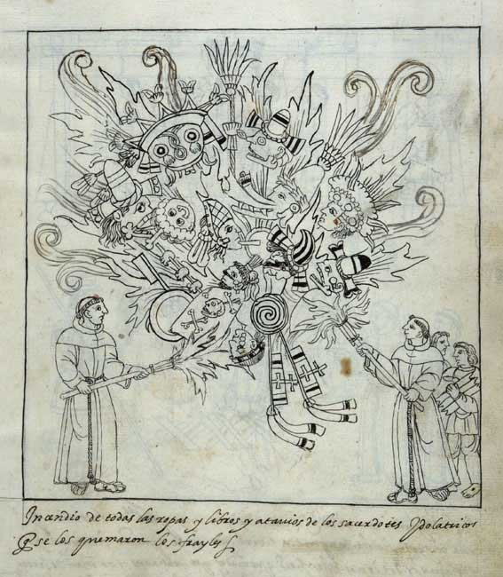

Document 4

Source: Sari Mehmed Pasha, a Turkish official in the early 1700s commenting on the traditional policies of the Sultan towards peasants, merchants, and government.

Let [the officials] neither oppress the poor [peasants] nor cause them to be vexed by the demand for new impositions in addition to the well-known yearly taxes which they are accustomed to give… The poor peasants should not be troubled. The people of the provinces and dwellers in the towns should be protected and preserved by the removal of injustices, and very great attention should be paid to making prosperous the condition of the subjects, making the districts joyous and flourishing and to protecting and preserving the property and lives of travelers on the road. . . . For it has been said that the basis of the ruler’s system is the man of consequence (honest, trained bureaucrat), and the raising of troops requires the paying of ready money by the Treasury, and the prosperity of the country comes through its healthy condition, and the flourishing of the country comes through the granting of justice and the punishment of oppressors.

Document 5

Source: The Shaikh Hasan Al Kafrawi, The Shafiite [Professor of Ialsmic law in Cairo, d. 1788 CE] regarding the rights of Jews and Christians in Muslim lands

The decision given by the Shaikh ar-Ramli*, by [the Muslim religious authority in Constantinople], and by the learned scholars... may be worded as follows: "It is forbidden to the tolerated peoples living on Muslim territory to clothe themselves in the same manner as the chiefs, the scholars, and the nobles. They should not be allowed to clothe themselves in costly fabrics which have been cut in the modes which are forbidden to them, in order that they may not offend the sensibilities of poor Muslims and in order that their faith in their religion should not be shaken by this.

"It is no longer permitted them to put themselves, with respect to their houses, on an equal footing with the dwellings of their Muslim neighbors, and still less to build their buildings higher… They shall no longer be permitted to repair the parts of [churches and synagogues built after Islam’s introduction] buildings which are in ruins. However, the old buildings [of pre-Islamic times] which are found in a land whose population had embraced Islam need not be destroyed. They shall not, however, be enlarged by means of repairs or otherwise. In case the tolerated peoples act contrary to these provisions we will be obliged to destroy everything that has been added to the original size of the building.

Entrance into Muslim territory by infidels of foreign lands under the pact guaranteeing protection to the tolerated peoples is permitted only for the time necessary to settle their business affairs. If they exceed this period, their safe-conduct having expired, they will be put to death or be subject to the payment of the head-tax. As to those with whom the ruler may have signed treaties, and with whom he, for whatever motive, may have granted a temporary truce, they form only the smallest fraction. But they, too, must not pass the fixed limit of more than four months [without paying the tax], particularly if this occurs at a time when Islam is prosperous and flourishing.

* [a great Cairo legal authority, d. 1596]

Modified DBQ Rubric 2020
Reporting Category | Scoring Criteria | Decision Rules
A THESIS/CLAIM  (0-1 pt) | 1 pt.  Responds to the prompt with a historically defensible thesis/claim that establishes a line of reasoning. | To earn this point, the thesis must make a claim that responds to the prompt rather than restating or rephrasing the prompt. The thesis must consist of one or more sentences located in one place, either in  the introduction or the conclusion.
B CONTEXTUALIZATION  (0-1 pt) | 1 pt.  Describes a broader historical context relevant to the prompt. | To earn this point, the response must relate the topic of the prompt to broader historical events, developments, or processes that occur before, during, or continue after the time frame of the question. This point is not awarded for merely a phrase or reference.
C EVIDENCE  (0-5 pts) | Evidence from the Documents | To earn one point, the response must accurately describe - rather than simply quote - the content from at least two of the documents.  To earn two points, the response must accurately describe - rather than simply quote - the content from at least two documents. In addition, the response must use the content of the documents to support an argument in response to the prompt  To earn three points, the response must accurately describe - rather than simply quote - the content from at least four documents. In addition, the response must use the content of the documents to support an argument in response to the prompt
1 pt.
Uses the content of at least two documents to address the topic of the prompt

2 pts.
Supports an argument in response to the prompt using two documents

3 pts.
Supports an argument in response to the prompt using at least four documents.
 | Evidence Beyond the Documents | To earn these points, each response must describe the evidence and must use more than a phrase or reference. These additional pieces of evidence must be different from the evidence used to earn the point for contextualization.
1 pt.
Uses at least one additional piece of specific historical evidence (beyond that found in the documents) relevant to an argument about the prompt.
2 pts.
Describes two unique pieces of specific historical evidence (beyond that found in the documents) relevant to an argument about the prompt.
D ANALYSIS AND  REASONING  (0-3 pts) | Evidence Analysis | To earn these points, the response must explain how or why (rather than simply identifying) the document’s point of view, purpose, historical situation, or audience is relevant to an argument about the prompt for each document sourced.
1 pt.
For one document, explains how or why the document’s point of view, purpose, historical situation, and/or audience is relevant to an argument.
2 pts.
For two documents, explains how or why the documents’ point of view, purpose, historical situation, and/or audience is relevant to an argument.
 | Argument Complexity | To earn this point, the response must explain how or why (rather than simply identifying) the document’s point of view, purpose, historical situation, or audience is relevant to an argument about the prompt for each of the three documents sourced.  A response may demonstrate a complex understanding in a variety of ways, such as:  - Explaining nuance of an issue by analyzing multiple variables  - Explaining both similarity and difference, or explaining both continuity and change, or explaining multiple causes, or explaining both cause and effect  - Explaining relevant and insightful connections within and across periods  - Confirming the validity of an argument by corroborating multiple perspectives across themes  - Qualifying or modifying an argument by considering diverse or alternative views or evidence  This understanding must be part of the argument, not merely a phrase or reference.
1 pt.
Demonstrates a complex understanding of the historical development that is the focus of the prompt, using evidence to corroborate, qualify, or modify an argument that addresses the question.

