Age of Revolutions Unit Assignments
You will work independently to complete one of the following assignment options. You will have time in class Tuesday – Friday (Oct 31 – Nov 3) and Monday (11/6). All parts are due at the end of class on Monday (Nov. 6th). This will count as a daily work AND assessment grade.
Option 1: Textbook Work
Complete the following textbook assignments. Each section should be clearly labelled. You should write questions and answers.
- English Revolution: pg. 617 #’s 1, 3-5, 8
- American Revolution: pg 645 #’s 1, 3-5, 7
- French Revolution: pg 676 #1-18
- Latin American Revolutions: pg. 686 #1, 3-6
- Russian Revolution: pg. 873 #1, 3-6

Option 2: Story Board
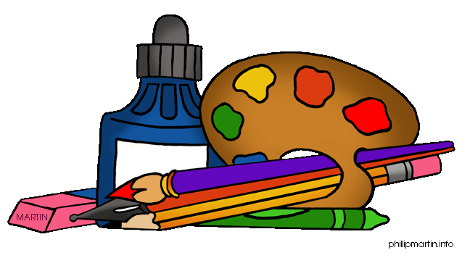
- Create an 8 panel story-board for 3 of the revolutions, illustrating and explaining important aspects and/or events about the various revolutions.
- Original drawings & story.
- See Mrs. Matello for more details.

Option 3: Board Game
- Create a trivia style board game about the various revolutions.
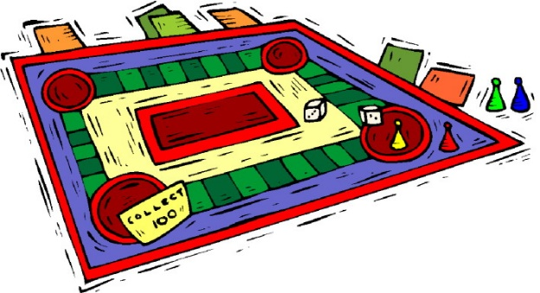
- See Mrs. Matello for more details.

