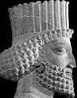
India – Mauryan Empire

Introduction
In 322 BC, Chandragupta Maurya founded the Mauryan Dynasty in India. Before the Mauryans, there had been hundreds of small kingdoms and armies, but the government formed by Chandragupta provided a stable, unified nation. This unity used local governors to control justice and security and allowed trade to expand and thrive. The trade that India engaged in along the Silk Road did well because of the fewer number of thieves on the roads and trade in India did well because of the single currency that Chandragupta established in India.

Chandragupta and Ashoka
Chandragupta began his rule by taking over the small kingdoms and armies that dominated India. An important idea of the Mauryan Empire was the central government. Chandragupta established the capital at Pataliputra and split the empire into four provinces to make ruling easier. The economy was another big accomplishment. Through the Khyber Pass, located on the border between Pakistan and Afghanistan, and on the Silk Road, Mauryans were able to trade with Greece, Hellenistic kingdoms, and the Malay Peninsula. The Mauryans main exports were silk, textiles, spices and exotic foods.
Chandragupta gave up the throne to Ashoka in 301 BC to become a monk (religious person.) Ashoka was the most important ruler in Ancient India. He was a brutal ruler who spread the empire throughout south and east India. After a devastating Battle of Kalinga in 260 BC, Ashoka and many Indian leaders converted to Buddhism.
As a result of Ashoka's conversion, Buddhism grew and the following changes occured:
- thousands of Buddhist schools and universities were built
- wildlife was protected resulting in the creation of the first ever national parks
- vegetarianism became wide spread
- Buddhist architecture spread throughout the world

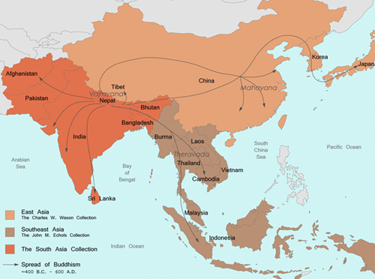
The figure below maps the spread of Buddhism from the 4th Century BC to the 6th Century AD

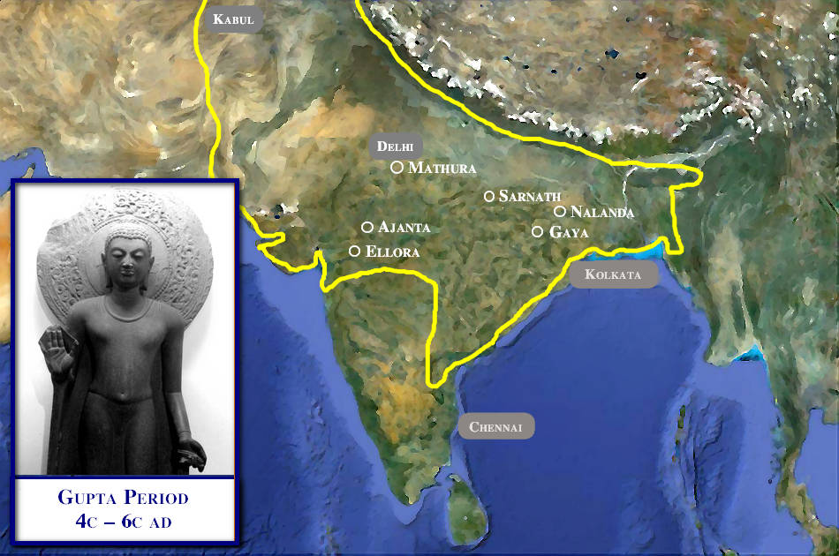
India
Gupta Empire – The Golden Age
The Gupta Empire was an ancient Indian empire that was founded in 320 CE and survived until about 550 CE. It covered most of north and central India, as well as Bangladesh. It was known to be one of the most peaceful and wealthy civilizations of its time. The Mauryan Empire fell in 185 BCE, after their final king was killed. For the next 500 years, India was at constant war.
When Chandragupta became emperor and began the notable empire in 320 CE, the time of darkness was reversed. Chandragupta set up a stable civilization with a strong government, but his son, Samudragupta, was the person responsible for making the empire larger. He took over Indian territories with little mercy. One unique tactic used by the ruler was using war elephants in his conquests.

Gupta Empire Accomplishments
Category | Accomplishments
Culture | - appreciated art  - tolerant of religions besides Buddhism  - peaceful & prosperous  - developed Sanskrit writing
Poetry and Literature | - most common forms of writing were narratives  - literature focused on human behavior instead of religion & philosophy  - fables used animals to tell comedic tales of wisdom  - many medical texts were written that had a great influence on health  - the emperor kept as many as 9 poets in his court
Math | - discovery of the decimal system and zero as a placeholder  - invention of numerals  - developed formula for the area of a triangle
Science and Astronomy | - discovered Earth was a sphere  - determined the length of the solar year as 365 days  - discovered the cause of lunar and solar eclipse  - proved that the Earth rotates around the sun and rotates on its own axis
Religion | - Buddhism and Hinduism were most prevalent religions  - Hindus eventually drove the Buddhists out to caves where they formed communities to live and worship

The Fall of the Gupta
It wasn't until about 455 CE that the Gupta Empire began to have trouble. All the power, wealth, and extravagant living led the rulers to become very lazy. They were invaded by the Huns and became weakened by the expense of war. The Huns took over India and split it into separate kingdoms. Eventually, war with the Hephthalites tribe devastated the Empire's economy and it fell.

