Name: ______________________________

**Exploring Document Based Questions: Understanding the Documents**

**Objective: SWBAT practice the point-scoring DBQ skill of contextualization by writing essay-beginning contextualization statements to multiple DBQ essay prompts.**

***Directions:*** As many of you have seen in my class text messages, or by continuing to track this important information on your own, the Collegeboard has decided that for the modified AP exam this year the format will be a DBQ. In order to make it more doable in 45 minutes, they have reduced the number of documents to five, and simplified the rubric to what you see here.

This week, we will spend each day isolating individual scorable skills and practicing them. Today, we will be targeting the next critical skill piece in making sure you score points in your response: **understanding the documents.**

For each of the DBQ questions you were shown yesterday, you will be given two documents and must explain how each of the documents answers the question. Breaking apart the question SLOWLY to be sure you fully understand what is being asked, is THE critical step needed to then apply that question to each document in order to understand it properly. Please see the example I provide for how this should ideally look.



*Example of describing the content of a document in a way that would score points given the DBQ question asked:*

**Using the documents provided, evaluate the effects of various strategies implemented by governments that promoted their own state-sponsored visions of industrialization during the period 1750-1900 CE.**

*(Document being referenced is shown on the next page)*

The effect of German state-sponsored industrialization shown in this document is more German people getting jobs. This effect is seen in the dramatic increase in numbers of German workers permanently employed in German Railway Construction. In 1850 there were 26,000 German workers permanently employed in the railway industry, and in only 23 years that number had increased to more than 230,000.

*Document used in the example (from previous page):*

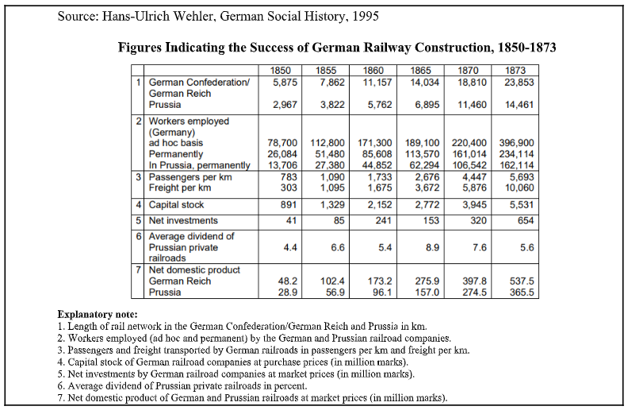

PRACTICE

1. **Using the documents provided, evaluate the extent to which the Industrial Revolution negatively impacted the lives of women and children in industrial societies during the nineteenth century.**

*Document #2*

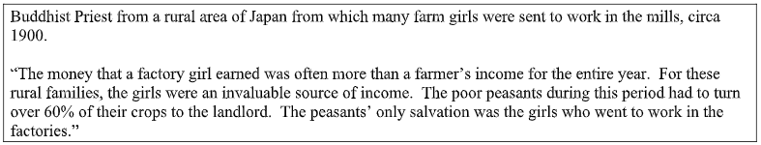

|  |
| --- |
|  |

*Document #5*

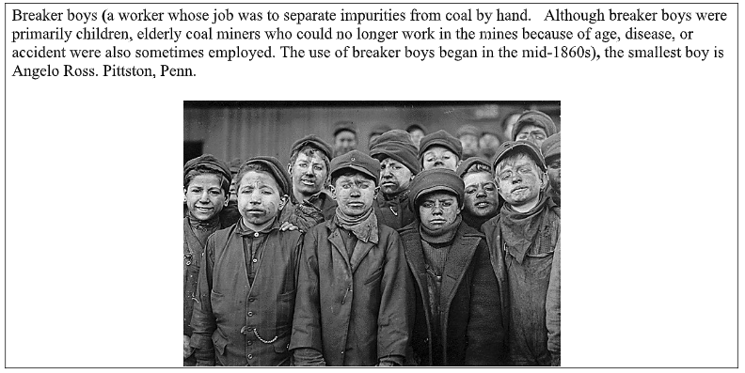

|  |
| --- |
|  |

1. **Using the documents provided, evaluate the causes of the rise of nationalism throughout the world during the period 1750-1900 CE.**

*Document #2*

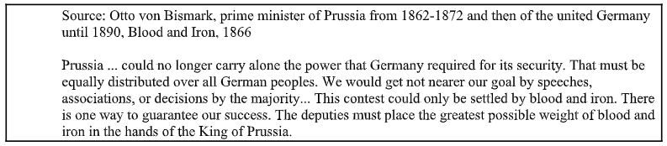

|  |
| --- |
|  |

*Document #4*

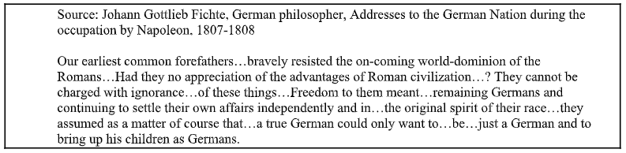

|  |
| --- |
|  |

1. **Using the documents provided, evaluate the extent to which Christianity changed societies in Latin America in the period 1500–1800.**

*Document #1*

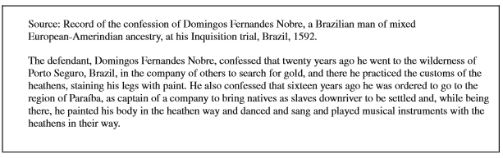

|  |
| --- |
|  |

*Document #5*

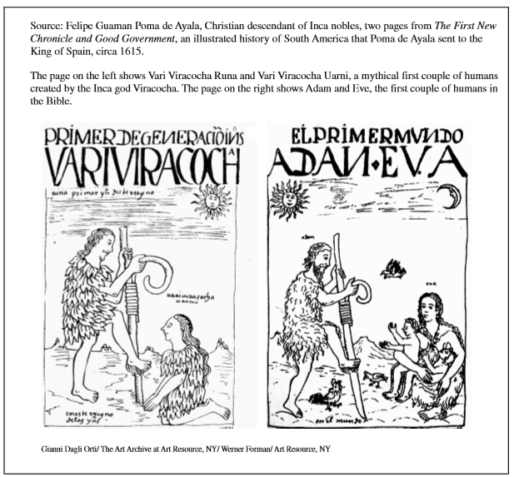

|  |
| --- |
|  |

1. **Using the documents provided, evaluate the extent to which the Chinese embraced Westernization in the period 1850 to 1920 CE.**

*Document #1*

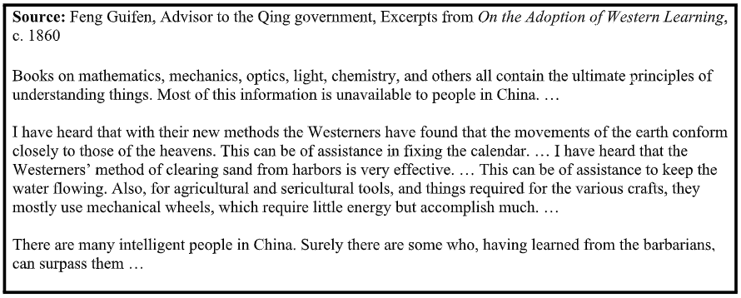

|  |
| --- |
|  |

*Document #2*

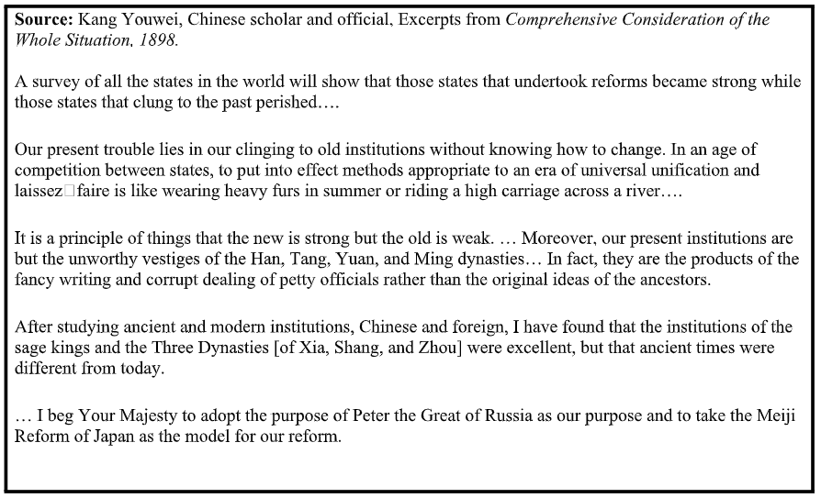

|  |
| --- |
|  |

1. **Using the documents provided, evaluate the range in African responses to European imperialist actions.**

*Document #2*

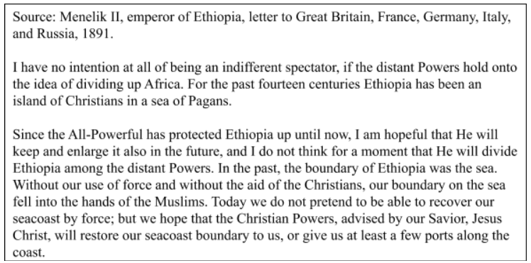

|  |
| --- |
|  |

**Document #3**



  
  
  