Name: ______________________________
Exploring Document Based Questions: Using the Documents to Support an Argument
Objective: SWBAT practice the point-scoring DBQ skill of using DBQ documents to support an argument that responds to the question
Directions: As many of you have seen in my class text messages, or by continuing to track this important information on your own, the Collegeboard has decided that for the modified AP exam this year the format will be a DBQ. In order to make it more doable in 45 minutes, they have reduced the number of documents to five, and simplified the rubric to what you see here.
This week, we will spend each day isolating individual scorable skills and practicing them. Today, we will be targeting the next critical skill piece in making sure you score points in your response: using two documents together to support an argument in response to the prompt
For each of the DBQ questions you were shown over the last two days, you will be given two documents and must explain what argument they both help make in response to the question. Breaking apart the question SLOWLY to be sure you fully understand what is being asked, is THE critical step needed to then apply that question in a way that lets you use the documents to make an argument that answers the question. Please see the example I provide for how this should ideally look.
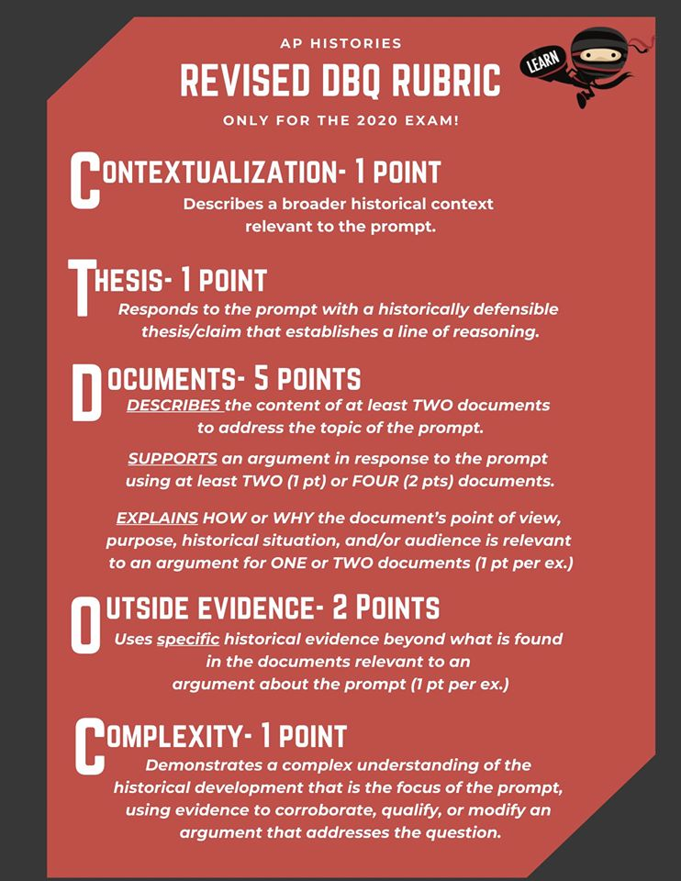
Example of how you would use two documents together to make an argument in response to the question:
Using the documents provided, evaluate the effects of various strategies implemented by governments that promoted their own state-sponsored visions of industrialization during the period 1750-1900 CE.
(Documents being referenced is shown on the next page)

When governments promoted their own state-sponsored visions of industrialization, it frequently led to a major increase in size of the economy. In Russia specifically, their industrialization led to a huge increase in economic performance, and by building 30,000 factories, their industrial production increased by 2,000,000,000 rubles (Document 3). This mirrored what happened in Japan, as their industrialization led to export increases from 50million Yen in 1878 to 500million Yen by 1908 (Document 7).

Documents used to write this example are on the next page…

Documents used in the example on previous page
DOCUMENT #3

DOCUMENT #7
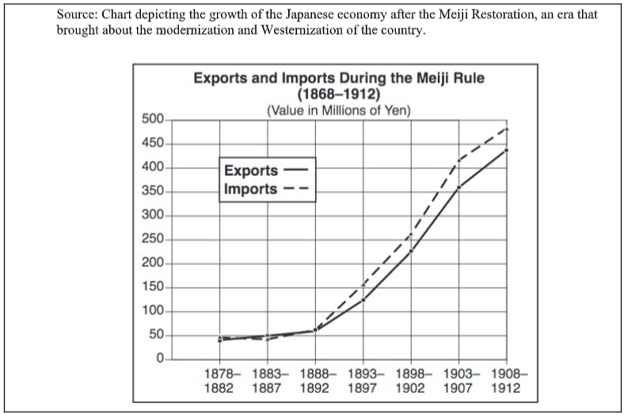

PRACTICE
- Using the documents provided, evaluate the extent to which the Industrial Revolution negatively impacted the lives of women and children in industrial societies during the nineteenth century.
Document #2
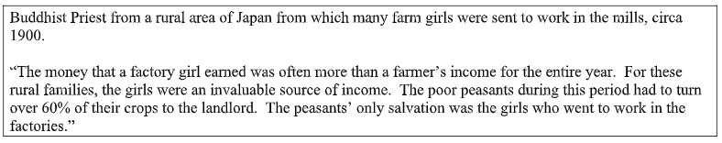
Document #4
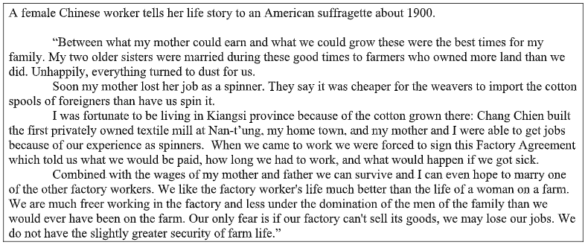

- Using the documents provided, evaluate the causes of the rise of nationalism throughout the world during the period 1750-1900 CE.
Document #1
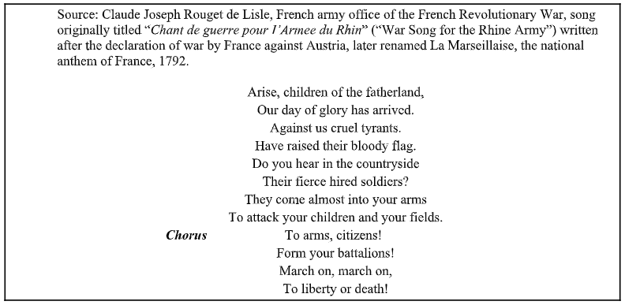
Document #5
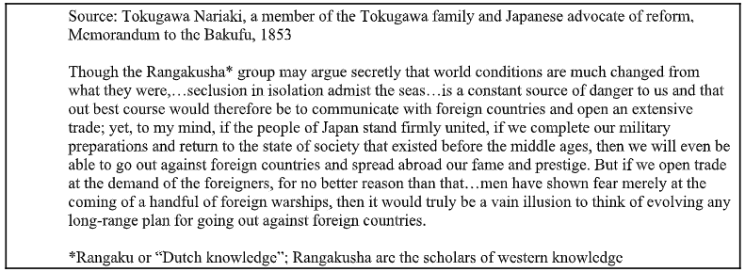

- Using the documents provided, evaluate the extent to which Christianity changed societies in Latin America in the period 1500–1800.
Document #3
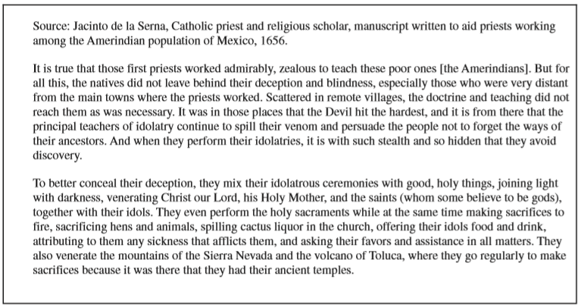
Document #4
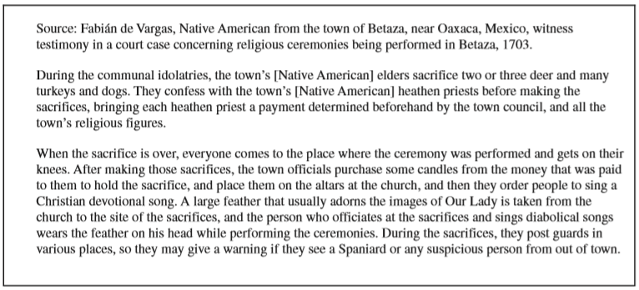

- Using the documents provided, evaluate the range in African responses to European imperialist actions.
Document #2
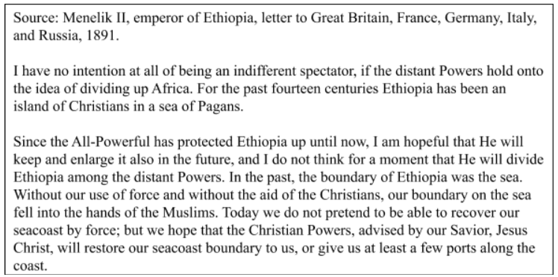
Document #7
