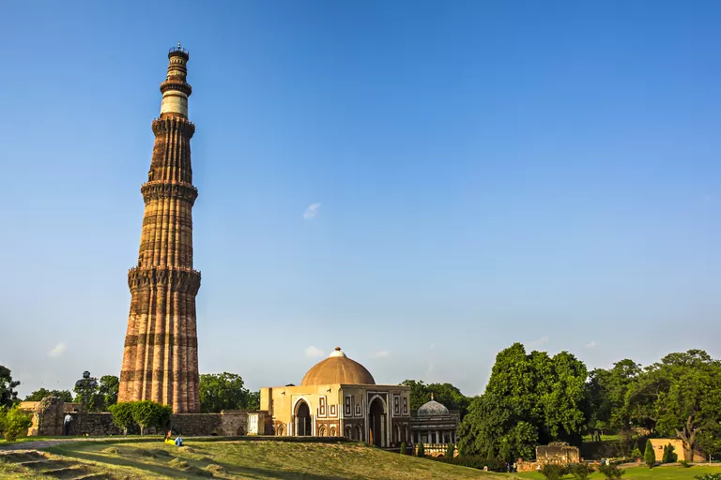
The Delhi Sultanates were a series of five different dynasties that ruled northern India between 1206 and 1526. Muslim former slave soldiers — mamluks — from the Turkic and Pashtun ethnic groups established each of these dynasties in turn. Although they had important cultural impacts, the sultanates themselves were not strong and none of them lasted particularly long, instead passing control of the dynasty to an heir.
Each of the Delhi Sultanates began a process of assimilation and accommodation between the Muslim culture and traditions of Central Asia and the Hindu culture and traditions of India, which would later reach its apogee under the Mughal Dynasty from 1526 to 1857. That heritage continues to influence the Indian subcontinent to this day.

The Mamluk Dynasty
Qutub-ud-Dïn Aybak founded the Mamluk Dynasty in 1206. He was a Central Asian Turk and a former general for the crumbling Ghurid Sultanate, a Persian dynasty that had ruled over what is now Iran, Pakistan, northern India and Afghanistan.
However, Qutub-ud-Dïn's reign was short-lived, as were many of his predecessors, and he died in 1210. The reign of the Mamluk Dynasty passed to his son-in-law Iltutmish who would go on to truly establish the sultanate in Delhi before his death in 1236.
During that time, the rulership of Delhi was knocked into chaos as four descendants of Iltutmish were placed on the throne and killed. Interestingly, the four-year reign of Razia Sultana — whom Iltutmish had nominated on his death bed — serves as one of the many examples of women in power in early Muslim culture.

The Khilji Dynasty
The second of the Delhi Sultanates, the Khilji Dynasty, was named after Jalal-ud-Dïn Khilji, who assassinated the last ruler of the Mamluk Dynasty, Moiz ud din Qaiqabad in 1290. Like many before (and after) him, Jalal-ud-Dïn's rule was short-lived — his nephew Ala- ud-din Khilji murdered Jalal-ud-Dïn six years later to claim rulership over the dynasty.
Ala-ud-din became known as a tyrant, but also for keeping the Mongols out of India. During his 19-year reign, Ala-ud-din's experience as a power-hungry general led to rapid expansion over much of Central and Southern India, where he increased taxes to further strengthen his army and treasury.
After his death in 1316, the dynasty started to crumble. The eunuch general of his armies and Hindu-born Muslim, Malik Kafur, attempted to take power but did not have the Persian or Turkic support necessary and Ala-ud-din's 18-year-old son took the throne instead, which he ruled for only four years before being murdered by Khusro Khan, bringing an end to the Khilji Dynasty.

The Tughlaq Dynasty
Khusro Khan did not rule long enough to establish his own dynasty — he was murdered four months into his reign by Ghazi Malik, who christened himself Ghiyas-ud-din Tughlaq and established a nearly century-long dynasty of his own.
From 1320 to 1414, the Tughlaq Dynasty managed to extend its control south over much of modern-day India, mostly under the 26-year reign of Ghiyas-ud-din's heir Muhammad bin Tughlaq. He expanded the borders of the dynasty all the way to the south-eastern coast of modern-day India, making its reach the largest it would be across all of the Delhi Sultanates.
However, under the watch of the Tughlaq Dynasty, Timur (Tamerlane) invaded India in 1398, sacking and looting Delhi and massacring the people of the capital city. In the chaos that followed the Timurid invasion, a family claiming descent from the Prophet Muhammad took control of northern India, establishing the basis for the Sayyid Dynasty.

The Sayyid Dynasty and Lodi Dynasty
For the following 16 years, the rulership of Dehli was hotly contested, but in 1414, the Sayyid Dynasty eventually won out in the capital and Sayyid Khizr Khan, who claimed to represent the Timur. However, because the Timur were known for pillaging and moving on from their conquests, his reign was highly contested — as were those of his three heirs.
Already primed to fail, the Sayyid Dynasty ended when the fourth sultan abdicated the throne in 1451 in favor of Bahlul Khan Lodi, founder of the ethnic-Pashtun Lodi Dynasty out of Afghanistan. Lodi was a famous horse-trader and warlord, who re-consolidated northern India after the trauma of Timur's invasion. His rule was a definite improvement over the weak leadership of the Sayyids.
The Lodi Dynasty fell after the First Battle of Panipat in 1526 duirng which Babur defeated the far larger Lodi armies and killed Ibrahim Lodi. Yet another Muslim Central Asian leader, Babur founded the Mughal Empire, which would rule India until the British Raj brought it down in 1857.

