Complete a One Pager for ONE of the Newsela articles from this unit. A One Pager is a visual summary of the contents of and your understanding/connection to a piece of text. Use the check-list below to help you!
Article Options:
- “Sharing News in the Digital Age”
- “Fake News Travels Faster on Twitter”
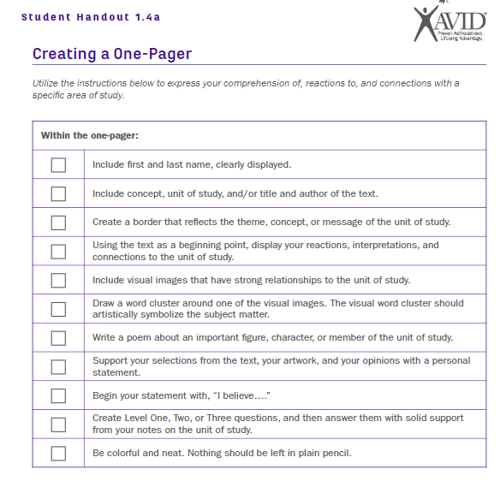
- “In Our Brains, Fake News Gets Baked”

