Document Analysis Exemplars
Q: What does a good document analysis attempt try and accomplish?
A: Assess the author’s point of view, OR identify what the author’s purpose may have been, OR assess how historical context may have played a role in the creation of the document, OR identify how the author’s intended audience may have impacted the message.
*******************
PLEASE NOTE: Each of these document analysis statements would follow the place in your body paragraphs where you had used information from that document to support your argument. In most situations the very next sentence after you cite your usage (ie “Document #7”) would be these analysis statements.
- Using the documents provided, evaluate the extent to which the Industrial Revolution negatively impacted the lives of women and children in industrial societies during the nineteenth century.
Document #6
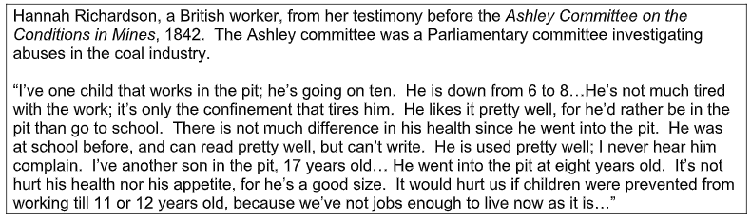
...Yet the author of this document, Hannah Richardson, is a member of the British working class testifying about her children’s work before the British Parliament. In her testimony she appears to be putting a positive spin on the work her children are doing in the mines, being careful not to make it seem too awful. Given how low the wages were and how poor the living conditions were for working class citizens in Britain at this time, it is possible that she may be speaking so positively because she is afraid that if she told the truth about the terrible working conditions for children in the mines, British Parliament may forbid the practice of child labor and her family would then lose the money her children are earning at a time when they very much depend on it.

- Using the documents provided, evaluate the causes of the rise of nationalism throughout the world during the period 1750-1900 CE.
Document #4
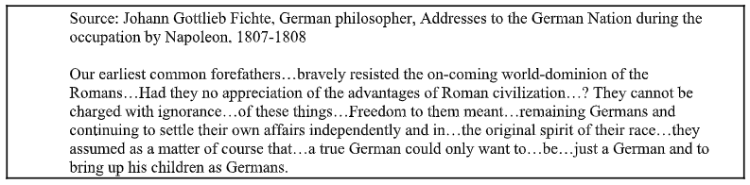
….The author of this speech, Johann Gottlieb Fichte appears to be invoking these powerful nationalist sentiments in order to specifically motivate German citizens countrywide to revolt and help drive the occupying French army led by Napoleon out of Germany. By giving this speech to the German nation, where he tells of the history of German citizens resisting Roman rule, he is hoping that the people will respond to these romanticized tales and be motivated to act similarly. Another potentially important piece in understanding this source better was the fact that Enlightenment ideas like the social contract and questioning who should rule, had become popular amongst peoples of the time, and Fichte appears to be invoking some of these ideas when he pushes for the German people to exercise their right to choose who rules them.

- Using the documents provided, evaluate the extent to which Christianity changed societies in Latin America in the period 1500–1800.
Document #4
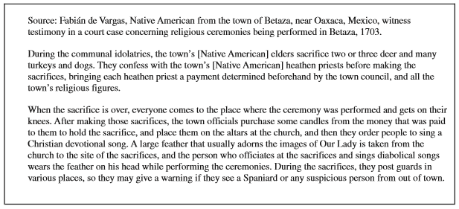
….It is possible, however, that when Fabian de Vargas is testifying in court on the un-Christian actions of the residents of Betaza that he may be doing so under threat of violence from the Spanish occupying force and therefore exaggerating or telling the court what he believes it wishes to hear. At this time in Latin American history, Spanish conquistadors pursued Christian conversion policies to throughout the region with accompanying threats of extreme violence. Consequently, a climate of fear towards the Spanish rulers developed for native Latin American people, and this fear could be having an impact on the validity of the words of witnesses in court whose testimonies may be given under pressure.

- Using the documents provided, evaluate the range in African responses to European imperialist actions.
Document #5
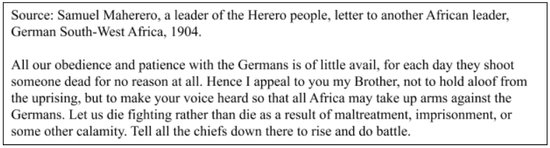
...It is clear that the words of Maherero in this document are driven by a desire on his part to convince other nearby African leaders to join him in his crusade. His use of the words “brother” and phrase “make your voice heard” is clearly designed to inspire action. Use of this type of rhetoric is most common in speeches, and given this apparent desire to rally other leaders to his side, it is possible that he may have exaggerated the circumstances some, as people tend to do when they are trying to be convincing.

