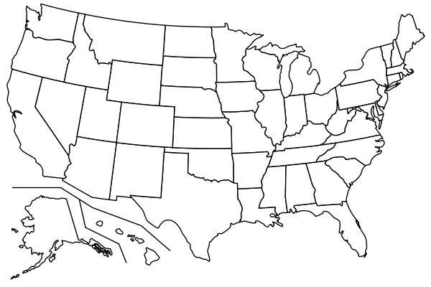



**Identify the following areas on the map provided based on the specific directions below.**

* Where are you from? (**Red**)
* Where have you travelled? (**Blue**)
* Where are you interested in travelling to? (**Green**)

Pictures speak a thousand words…

If you’re interested, add some pictures from your travels or things you want to see when you get to travel!

\

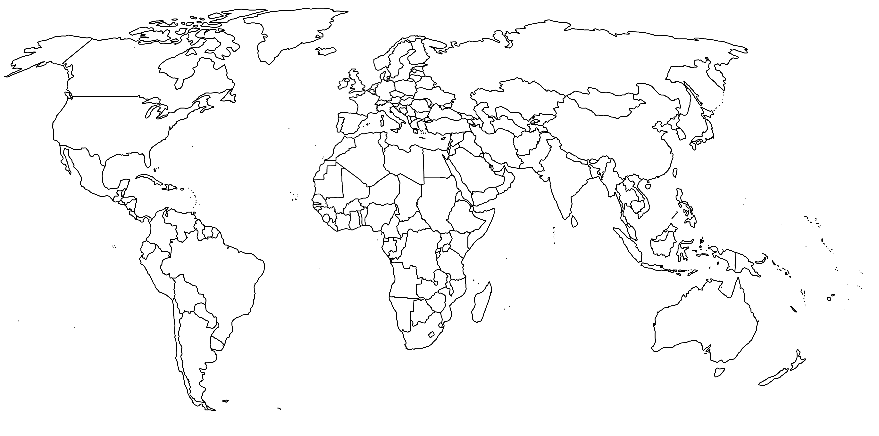



Pictures speak a thousand words…

If you’re interested, add some pictures from your travels or things you want to see when you get to travel!

**Identify the following areas on the map provided based on the specific directions below.**

* Where are you from? (**Red**)
* Where have you travelled? (**Blue**)
* Where are you interested in travelling to? (**Green**)