Impact of European Exploration and Colonization
SSWH10 Analyze the causes and effects of exploration and expansion into the Americas,
Africa, and Asia.
a. Explain the roles of explorers and conquistadors.
b. Analyze the global, economic, and cultural impact of the Columbian Exchange.
d. Examine the effects of the Transatlantic Slave Trade on Africa and on the colonies in the Americas.​

Impact of European Exploration and Colonization
- Christopher Columbus first arrives in the _________________________ in ___________.
- 1501 – Portuguese explorer ____________________________ claims that the lands discovered by _____________________ was not ___________, but rather ___________________________________.
  - 1507:
- Over the next 200 years, other ____________________ explorers sail across the _________________ in search of new lands to claim.

Line of Demarcation and the Treaty of Tordesillas
- Rivalyry between ________________ and _________________ over territory in the new world was very intense.
- 1493: ________________________________ suggests dividing the territory
  - ___________________________________: imaginary dividing line drawn north to south through the _______________________
    - All territory to the west =
    - All territory to the east =
- 1494: Sprain and Portugal sign the _________________________________ - moves the Line of Demarcation further _______________.
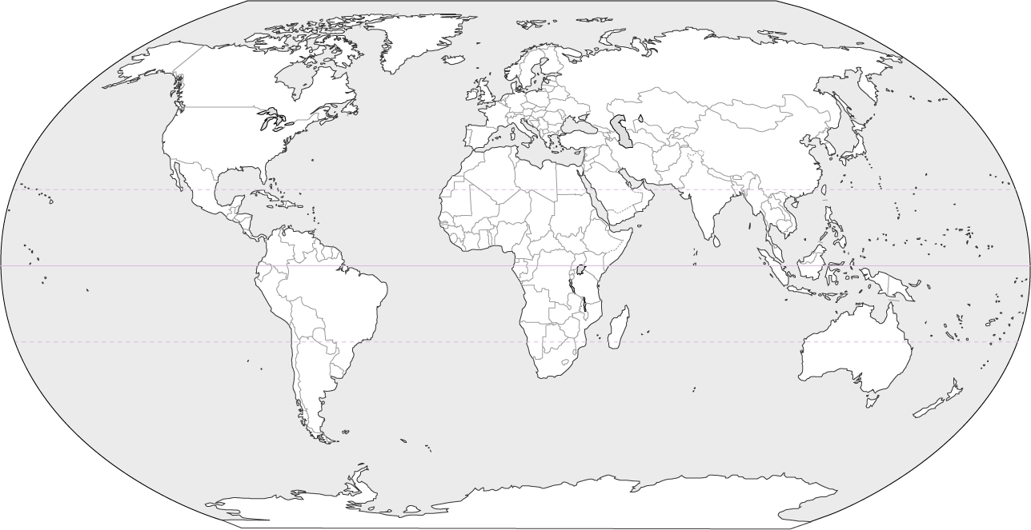

Central and South America | North America
- Conquistador:  - 1519-1521: _______________________ defeats the ______________  - Montezuma II:  - 153: ___________________________ defeats the ______________.  -  - By the middle of the 16th century, Spain has an _____________________________. | - Northwest Passage:  - France establish colony (_________________) in modern day __________________.  -  - English establish colony in ____________________, ________________  - _______________ establish a colony called New Netherland in modern day ______________________

The Atlantic Slave Trade
Atlantic Slave Trade
- Europeans seek __________________________ - begin using enslaved Africans.
- Atlantic Slave Trade:
- Between 1500 and 1600, nearly _____________ Africans were transported to the Americas
- 1700s:
Causes of African Slavery

Triangular Trade
-

-

-

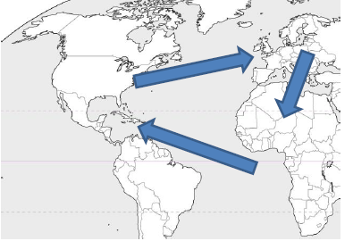

Consequences of the Slave Trade
- Africa
  - Numerous _____________ lost nearly whole _________________ og their young and able.
  - Countless families were torn apart.
  - The introduction of _____________ into Africa led to increased ______________ and _________ there.
- Americas
  - Africans brought their ____________, ______________, _______________, and ________________ with them, and those helped shape ______________ in the ________________.
  - South America and Latin America have large _____________________ populations
Slavery in the Americas
- Upon arrival, humans were auctioned off on the docks.
- Their lives were brutal, with hard work from dawn to dusk, with regular beatings.
- Resistance:

Middle Passage
- The trip that took enslaved humans form ______________ to the ________________________ was called the Middle Passage.
- About ___________ of those taken _____________ aboard the ships.
- The people were beaten and poorly fed, while _______________ allowed _____________ to spread rapidly.

Columbian Exchange

Evolution of Trade
- Before the _____________ ____________________, long distance _______________ was very risky.
  - Ships could be lost to:

- If a merchant owned __________ of a ship’s cargo, he/she would incur ____________ of the risk.
- ________________________________ allowed people to share the _____________ and __________________. A merchant could own 10% of 10 different ships and still make a good living.
Capitalism
- Capitalism is an ______________________________ based on ____________ ownership, investment, and the possibility of _________________.
- Previous economic systems were based on the _________________________ (king) owning everything.
- Capitalism increased ______________, which also increased the _______________________ - which leads to increased __________________ (inflation)
Mercantilism
- European countries, especially ___________________ and _________________, began to compete for _________ as well as _____________.
- Mercantilism is a way to gain more ___________ for your own ____________, while draining _________ from your ________________.
- _________________ helped with this system, since they produced ______________________ (cotton), but not ____________________________________ (cloth). (Triangular Trade)
- Colonists also became _______________ of the manufactured goods from their __________________ __________________.

Review

