Name:
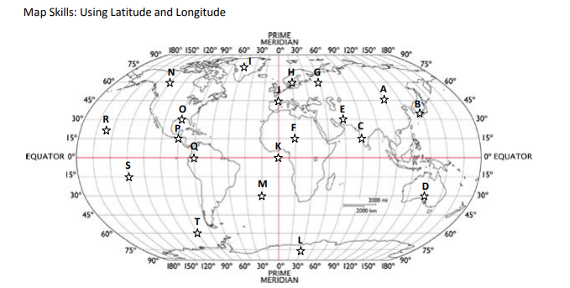
Directions: Use this map to identify the latitude and longitude coordinates of each star.

Letter of the Star | Degree of Latitude | N or S | Degree of Longitude | E or W
A
B
C
D
E
F
G
H
I
J
K
L
M
N
O
P
Q
R
S
T

