Medieval Africa (1200​-1450 C.E.) Differentiated Learning Stations

Station 1 – Audio Lecture 1  - Go to link https://bit.ly/reactingtoglobalizatio​n  - If this is your first​ audio lecture station, listen to​ the lecture from 0:00-9:05.  If this is your second audio​lecture station, listen to the lecture from 9:05-18:35.  - Answer the questions in this packet as you listen to the lectures. | Station 3 – Verbal (Linguistic): Marco Polo & Ibn Battuta  - Read the one page article​ entitled ​“Marco Polo and Ibn Battuta: The Merchant and the Pilgrim.” (for some techy reason, the article is sideways and upside down. If you download the PDF into Adobe or another reader, you can turn it as you need.)  - Complete questions 1-5 on the attached pages corresponding to the article.  - Analyze the map​ (in the box below) of the travels of Marco Polo & Ibn​Battuta. Then place an “x” in the attached chart showing which traveler visited which geographic locations. (question #6)
Station 2 – Audio Lecture 2  - Go to link https://bit.ly/reactingtoglobalizatio​n  - If this is your first​ audio lecture station, listen to​ the lecture from 0:00-9:05.  If this is your second audio lecture station, listen to​the lecture from 9:05-18:35.  - Answer the questions in this packet as you listen to the lectures. | 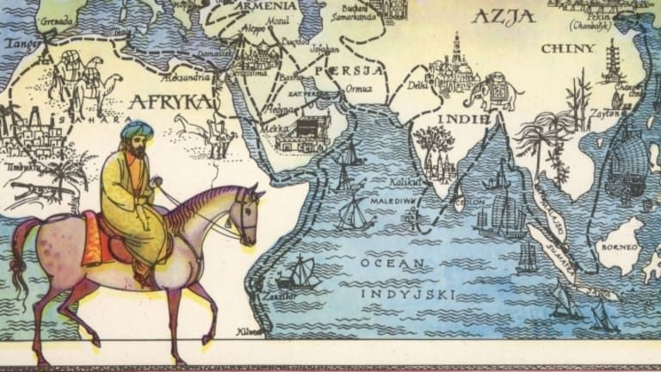
Station 4 – Visual  “Crash Course in World History” – Mansa Musa and Islam in  Africa http://youtu.be/jvnU0v6hcU​ o  - Most of African history was preserved by ___________ tradition.  - Why did the Mali ruler Mansa Musa leave his kingdom? Where was he going?  - Name three major effects​ of Mansa Musa’s pilgrimage:​  ●  ●  ●  - What was the largest and most famous city of the Mali Empire?  - Which group of trading peoples spread Islam to West Africa and what two major items did they trade with west Africans?  - What was the first empire in West Africa, which existed in the 11​^{th​} century before Mali?  - The eastern coast of Africa saw the rise of Swahili civilization, which was not an empire or kingdom, rather a collection of ______________ ___________________.  7. Which west African linguistic group spread their language, the use of iron, and their knowledge of agriculture to eastern Africa? | Station 5 – Logical (Mathematic)  Document Analysis  * Read the primary sources at http://bit.ly/mansamusadocuments and answer the following questions:  Doc A:  - What percentage of travelers on the hajj were Mansa Musa’s personal servants?  - Which of the numbers in this chart might be exaggerations? Explain your thinking.  Doc B:  - What is your estimate on the time it would take Mansa Musa’s caravan to travel from Niani to Cairo? How did you reach your estimate?  - Which two commodities seem most important to the trans-Saharan trade?  Doc F:  - How is Mansa Musa described in the caption to the right?  What might Europeans think about western Africa after viewing The Catalan Atlas?

Stations 1 & 2 (Audio Lecture Questions) iTunes U “Reacting to Globalization”

0:00-9:05
- Interaction between regions: nomadic invasions, empires, universal religions, and the Silk Road among many other things all brought different peoples into _____________________ with one another.

- Sea routes began to be developed by _____________________ traders as a means of bypassing land that was controlled by rival kingdoms and as a means of moving goods more quickly.

- _________________________ remained the most active traders, but trade centers sprung up on the coast of sub-Saharan Africa, India, and in China.

- Sub-Saharan African kingdoms traded ___________, ____________, and ______________ for Eurasian goods.

- In West Africa the kingdom of __________________ overtook the kingdom of _________________ by 1200
CE.

- Mali's most famous and wealthy ruler was _____________ ________________. He became famous for his pilgrimage to ___________________ in which he distributed a tremendous amount of gold along the way.

9:05-18:35
- Along with the Middle East, South Asia (India) was also a "crossroads" of Afroeurasian trade. Because of this, they were very active in ______________.

- __________ was a more social and emotional form of Islam that developed among the lower classes; it had its roots in folk religions and was easier to adopt by a wide variety of people. It played a large role in spreading Islam into Africa and South Asia.

- India was subject to Muslim invasion around 1000 C.E. Name at least two effects of this:

a.

b.

- In China during the Song Dynasty (960-1276 CE) was the largest and most prosperous nation in the world. During this period, China drove the world's _________________________.

- The Civil Service Exam in China continued to take power away from ________________ ________________ and put it in the hands of the most qualified people. Because of this there was much more social mobility in China between classes.

- Despite their advanced civilization, the Chinese were very _______________________ of outsiders, who they considered to be inferior barbarians.

Station 3

Marco Polo and Ibn Battuta: “The Merchant and the Pilgrim”​
Directions:​ Read the article and answer the following questions on the paper below.
- The Italian Marco Polo left his home in Venice in 1271 C.E. How many years passed before he returned from China?

- The Islamic jurist Ibn Battuta left his home in Tangier, Morocco in 1325. How many years was it before this famous world traveler returned home?

- How were Battuta & Polo “aided” on their journeys to the Far East?

- Discuss the ways in which Marco Polo was an “outsider” whereas Ibn Battuta was considered an “insider” during both of their world travels.

- Describe the differences in the accounts of Marco Polo’s “Travels” and Ibn Battuta’s “Rihla.”

- Study the maps of the Journeys of Marco Polo and Ibn Battuta. Place an “X” in the box below, showing which traveler visited which geographic locations:

Locations Visited: | Marco Polo | Ibn Battuta | Both Travelers
Mediterranean Sea
Baghdad
Nile Valley
Mecca
Constantinople
Delhi
Sahara Desert
Silk Road
China
Strait of Malacca

