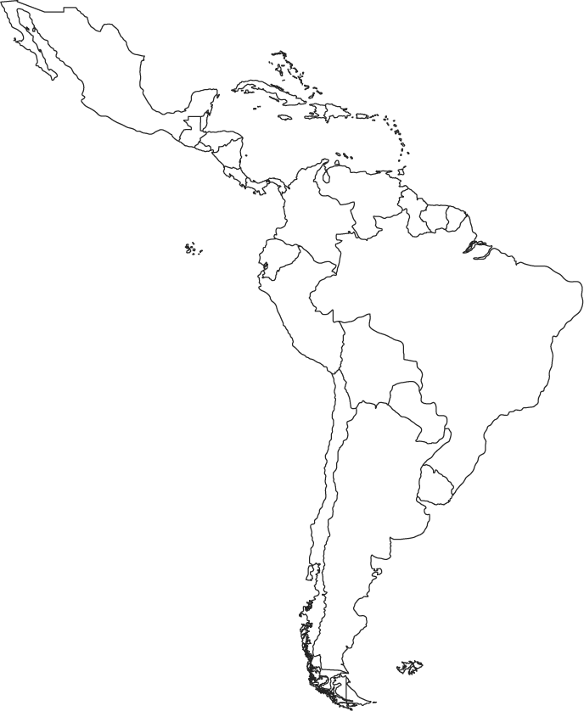
Mesoamerican Civilization Map

Shade in the areas occupied by the Mesoamerican societies:
Maya

Inca

Olmec

Aztec

Label the following countries and physical features on the map:
Mexico, Peru, Honduras, Guatemala, Belize, Venezuela, Atlantic Ocean, Pacific Ocean, Gulf of Mexico, Yucatan Peninsula

