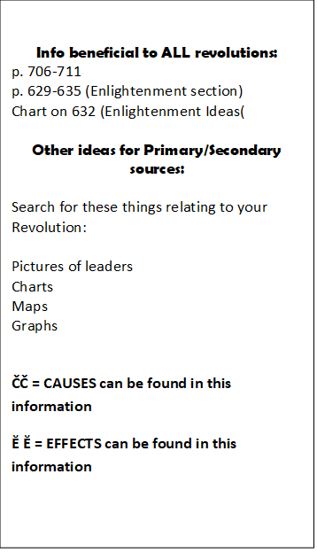
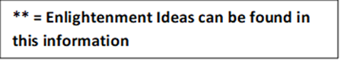

English Civil War & Restoration (595, 614-617)
- ČČ Why? (p. 595) Growing Power & Crises Lead
- ČČ Why? (p. 614) Setting the Stage, James's Problems & **Charles I Fights
- War topples King
- Cromwell’s rule
- Puritan Morality
- Charles II Reigns
- James II and the Glorious Revolution
- Ĕ Ĕ Bill of Rights
- Ĕ Ĕ Cabinet System Develops
Suggested Primary/Secondary Sources:
- English Bill of Rights

American Revolution (640-645)
- ČČ Why? Setting the Stage & Britain and Its American Colonies
- America wins Independence
- Growing hostilities
- **Influence of Enlightenment
- Success for Colonists
- Democracy
- Weak national government
- Ĕ Ĕ New constitution
- Ĕ Ĕ Federal system
- Ĕ Ĕ Bill of Rights
Suggested Primary/Secondary Sources:
- Declaration of Independence
- US Bill of Rights to the Constitution

Latin American Revolutions (675, 681-686, 818-821)
- ČČ Why? (p. 675) Revolution in Latin America
- ČČ (p. 681) Colonial society divided
- **ČČ Creole’s lead revolutions
- Bolivar’s Route to Victory
- San Martin Leads Southern Liberation
- Ĕ Ĕ Struggling Toward Democracy
- **Revolution in Haiti
- Haiti’s Independence
- Reading 1
- Reading 2
- Reading 3
- Ĕ Ĕ http://library.brown.edu/haitihistory/8.html
- Ĕ Ĕ https://www.britannica.com/topic/Haitian-Revolution
- Brazil’s Royal Liberator
- (p. 818) Cuba Declares Independence

French Revolution (595, 651-661, 663)
- ČČ Why? (p. 595) Growing Power & Crises Lead
- ČČ (651) Setting the Stage
- ČČ Old Order/Privileged Estates
- ČČ The Third Estate
- **Enlightenment ideas
- Economic troubles
- Weak leader
- National Assembly
- Storming the Bastille
- Great Fear
- Assembly Reforms France
- Limited Monarchy
- France at War
- Jacobins
- Robespierre
- Reign of Terror
- Ĕ Ĕ End of Terror
- Ĕ Ĕ (p. 663) Naploeon Seizes Power
Suggested Primary/Secondary Sources
- Ĕ Ĕ Declaration of the Rights of Man and the Citizen
- History in Depth p. 600
- p. 652 political cartoon

Napoleon (661, 663-675)
- ČČ Why? (p. 661) End of Terror
- ČČ (p. 663) Napoleon Seizes Power
- Coup d’Etat
- **Napoleon Rules France
- Restoring Order at Home
- Napoleon Crowned Emperor
- Loss of American Territories
- Conquering Europe
- The Battle of Trafalgar
- The French Empire
- Napoleon’s Costly Mistake (668)
- The Peninsular War
- The Invasion of Russia
- Napoleon Suffers Defeat
- The Hundred Days
- Metternich’s Plan for Europe
- The Containment of France
- Ĕ Ĕ Balance of Power
- Ĕ Ĕ Legitimacy
- Ĕ Ĕ Conservative Europe
- Ĕ Ĕ Long-Term Legacy
Suggested Primary/Secondary Sources
- Search for a pic of Napoleon on the Throne
- Map on pg 670
Russian Revolution (690-691, 867-873)
- ČČ Why? (p. 690) Reform in Russia
- ČČ Defeat Brings Change
- Reform and Reaction
- **(p. 867) Setting the Stage
- Czars Continue Autocratic Rule
- Russia Industrializes
- **The Revolutionary Movement Grows
- The Russo-Japanese War
- Bloody Sunday: The Revolution of 1905
- World War I: The Final Blow
- The March Revolution
- The Czar Steps Down
- Lenin Returns to Russia
- The Bolshevik Revolution
- The Provisional Government Topples
- Bolsheviks in Power
- Ĕ Ĕ Civil War Rages in Russia
- Ĕ Ĕ Lenin Restores Order
- Ĕ Ĕ New Economic Policy
- Ĕ Ĕ Political Reforms
- Ĕ Ĕ Stalin Becomes Dictator

Mexican Revolution (674, 685-686, 822-827)
- ČČ Why? (p. 674) Revolution in Latin America
- **ČČ (p. 685) A Cry for Freedom
- ČČ (p. 822) Setting the Stage
- Santa Anna and the Mexican War
- The Texas Revolt
- War and the Fall of Santa Anna
- Juarez Rises to Power
- Juarez Works for Reform
- The French Invade Mexico
- Porfirio Diaz and “Order and Progress”
- Madero Begins the Revolution
- Ĕ Ĕ Mexican Leaders Struggle for Power
- Ĕ Ĕ The New Mexican Constitution
Suggested Primary/Secondary Sources:
- Grito de Dolores

