Name:________________________________________________________ Date:_________ Period:_______
Unit 2: Topic 2.5 Cultural Consequences of Connectivity Map

Learning Objective: Explain the intellectual and cultural effects of the various networks of exchange in Afro-Eurasia from c. 1200 to c. 1450.

Annotate this map and complete this handout with notes from the presentation and pgs. 111-116 in your AMSCO book.

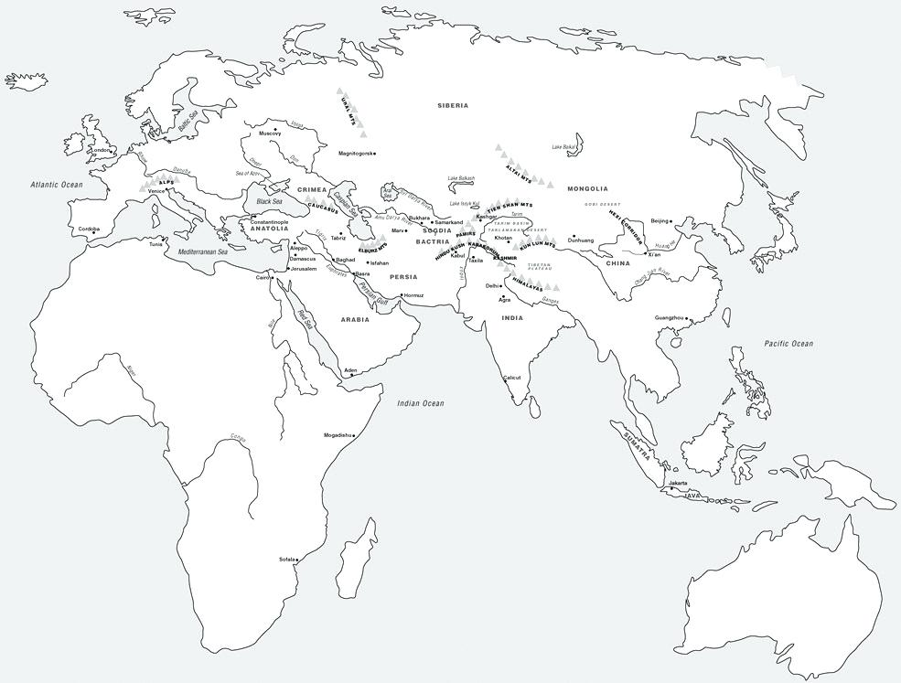 | Diffusion of cultural traditions:  - Spread of Buddhism  - Spread of Hinduism  - Spread of Islam  Diffusion of scientific or technological innovations:  - gunpowder  - paper  Major trading cities:  - Timbuktu  - Kilwa  - Samarkand  - Kashgar  - Malacca  - Guangzhou (Canton)  - Calicut  - Venice  Travelers:  - Route of Marco Polo  - Route of Ibn Battuta

Impacts of Islam  (include examples of syncretism) | Impacts of Buddhism  (include examples of syncretism) | Impacts of Hinduism  (include examples of syncretism)

Intellectual Effects of Networks of Exchange  c. 1200 - 1450. | Cultural Effects of Networks of Exchange  c. 1200 - 1450.

