Unit One
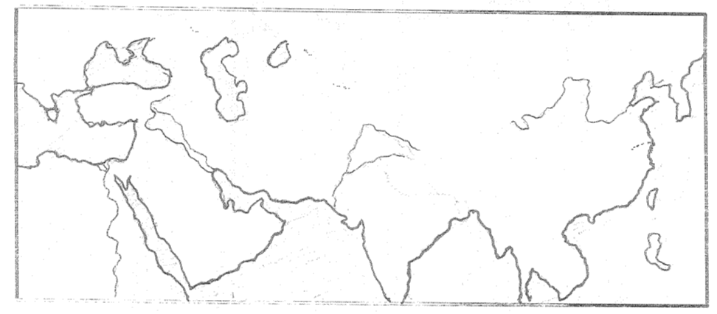
Define/Explain the following terms:

- Monotheism
- Polytheism
- Animism

How was Judaism different from other
Mesopotamian religions?

Identify the FOUR RVC’s on the map to the right

Define/Explain the following terms:
- Patriarchal Society
- Theocracy
- Social Hierarchy
- Silk Road

Name the writing type for each of the following civilizations:
- Mesopotamia
- Phoenicians
- Egypt
- Indus Valley

Why did the Mesopotamian civilization develop in the Tigris-Euphrates river valleys? Hint: What did it provide?

Name the similarities between Olmecs, Mesopotamians, Egyptians, and the people of the Huang He River Valley?

What were the causes and effects of the Bantu Migration?

In what region was the Olmec Civilization located?

Unit Two

Define/Explain the following terms:

- Republic
- Polis
- Hellenistic Culture
- Alexander the Great
- Justinian’s Code

What caused the fall of the Roman Empire?

“Western Europe owed a debt of gratitude to the Empire that for almost a thousand years ensured the survival of Christianity during a time when Europe was too weak to accomplish the task.”
Which Empire is referred to in this quotation?

Discuss the similarities and differences between Athens and Sparta. (Focus on major achievements, social characteristics, and political structures)

What impact did the Byzantines have on the Russians?

Unit Three

Define/Explain the following terms:

- Muhammad
- Baghdad’s House of Wisdom
- Trans-Sahara Trade Network
- Mansa Musa
- Kublai Khan

What are the major contributions of the Islamic Empire?

How were conquered peoples treated by the Muslim Empire?

One similarity between the Ancient African kingdoms of Egypt, Ghana, Mali and Songhai is that all of these kingdoms were located

Unit Four

Define/Explain the following terms:
- Renaissance
- Nicollo Machiavelli
- Magna Carta
- Serfs
- Martin Luther
- 95 Theses

What caused the Middle Ages?

What was the main cause of the Black Death (Bubonic Plague?)

“All things were under its domain…its power was such that no one could hope to escape its scrutiny.”
Which European institution during the Middle Ages is best described by this statement?

What were the cuases and effects of the Crusades?

Discuss the results of the Printing Press

In what ways was the Renaissance different from the Middle Ages?

What were the immediate effects of the Reformation?

What was one major influence the Renaissance had on the Protestant Reformation?

